Forum: Environment Commission
Issue: Addressing the increased environmental toll incurred by the advent of AI
Student Officer: Ethan Zhu
Position: Deputy President

Introduction
In light of recent global strides towards artificial intelligence (AI), environmental activists have grown concerned with the environmental impacts of the newest stride in technology. In fact, in 2025, reports claim that the AI boom has caused the same CO₂ emissions as the entire city of New York. Researchers have found that the carbon footprint of AI systems could be as high as 80 million tons annually, while the water used could reach 75 billion liters. Tech giants have hundreds of data centers worldwide, each with about 50,000 servers that the company uses to support cloud computing services. While some countries have made strides in environmental regulation in AI systems, others have been less adamant. As a result, an international effort is needed to create a comprehensive solution to this crisis.
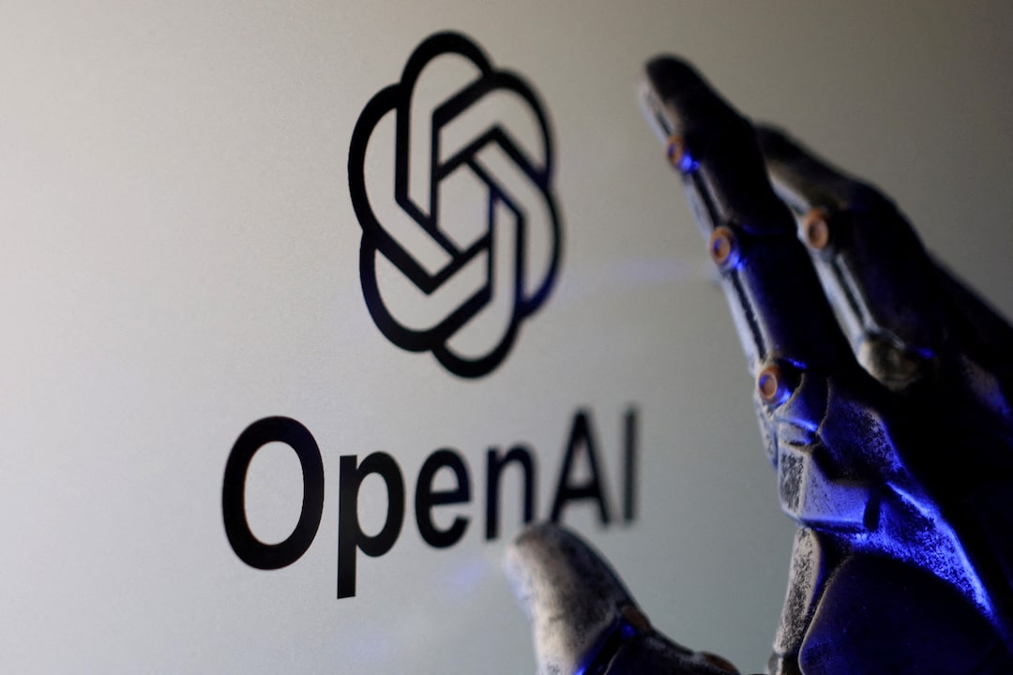
Figure #1: Visual Representation of OpenAI, the Creator of ChatGPT

Definition of Key Terms

Artificial Intelligence (AI)
Artificial intelligence is the ability of a digital computer or computer-controlled robot to perform tasks commonly associated with intelligent beings. AI is developed to intellectually process things like humans, often containing similar characteristics such as the ability to reason, discover meaning, generalize, or learn from past experience.
Data Centers
Data centers are specialized facilities designed to house and manage a vast array of computer systems, servers, networking equipment, and storage infrastructure. Data centers have also evolved from on-premises facilities to solutions that can connect these physical structures with cloud infrastructures, where networks, applications, and workloads are virtualized in private and public clouds.
Carbon Footprint
A carbon footprint is the amount of CO₂ or CO₂ equivalent emissions associated with domestic final use and directly emitted by households. These include both emissions by residents and emissions elsewhere that are due to consumption and gross capital formation. Carbon footprints are measured in kg CO₂ (equivalents) per capita.
Energy Consumption
Energy consumption is the amount of energy, whether in liquid, solid, gaseous, or electric state, used by an individual in a given year in a given geographical area. Energy consumption is measured in gigajoules and is often closely linked with economic and environmental factors, like population growth and production of ozone depleting substances.
Water Usage (Cooling Systems)
All cooling towers, whether commercial or residential, consist of heat exchangers that rely on water, which circulates through the HVAC system, absorbing heat. This warm water then gets pumped to the top of the cooling tower, where is passes through the fill media and cools down through evaporation. The cooled water then returns to the HVAC system to absorb more heat, while some of the remaining water is evaporated in the process.
Electronic Waste (E-waste)
E-waste is used to describe discarded electronic appliances, including smartphones, mobile devices, tablets, laptops, computers, and hard drives. These forms of waste are often formed when devices and hardware systems are discarded rather than being recycled or stripped for parts. They are simply thrown out into a landfill site.
Green Computing
Green computing is the design, manufacture, use, and disposal of computers, chips, and other technology components and peripherals that limit harms to the environment. Also known as green IT or sustainable IT, green computing also includes choosing sustainable options for raw materials, reducing electronic waste through the use of renewable resources.
Sustainable Development
Sustainable development is development that meets the needs of the present without compromising the ability of future generations to meet their own needs. The UN has set 17 Sustainable Development Goals (SDGs) to secure the rights and well-being of everyone on a healthy, thriving planet, along with the 2030 Agenda for Sustainable Development.
Life-Cycle Assessment (LCA)
Life-cycle assessment (LCA) is the process of evaluating the effects that a product has on the environment over the entire period of its life, thereby increasing resource-use efficiency and decreasing liabilities. LCAs can be used to study the environmental impact of either a product or the function the product is designed to perform. LCA’s often look at the quantity of environmental loads involved, the energy and raw materials consumed, the missions and wastes generated, the potential environmental impacts of these loads, and other alternative options for reducing the environmental impacts.

History & Developments

Growth of Artificial Intelligence
As the turn of the century arrived, artificial intelligence began to explode in technology. In 2003, NASA successfully landed two rovers onto Mars, where they were able to navigate the surface of the planet without any human intervention. In 2006, companies like Twitter and Facebook began implementing AI into their advertising and user experience algorithms. Most notably, Apple released Siri in 2011, the first popular virtual assistant. Seeing the success of these initiatives, some companies began actively developing newer and better AI models, including OpenAI, who had started beta testing GPT-3 in 2020, an AI model that uses Deep Learning to create code, poetry, and other writing tasks. Eventually, in 2022, OpenAI released the AI chatbot ChatGPT, garnering users all over the world.
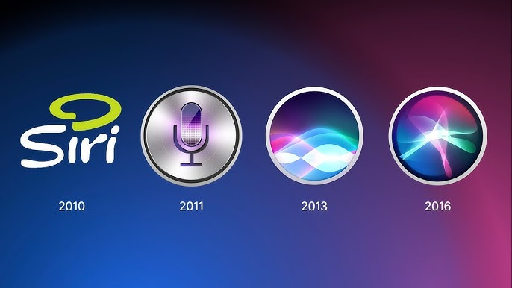
Figure #2: Siri’s Evolution Since Beta Testing

Computing Infrastructure Expansion

To match growing AI models and machinery, computing infrastructure also needed to improve. The very concept of data centers began to take shape in the 1950s and 60s, where the primary goal of these facilities was to store and process critical data for decision-making. These early data centers were known as mainframes, which were massive machines that processed data offline and were also not interconnected through networks. Eventually, in the 1970s, the first official data center was constructed by the IBM, where an emphasis on controlled environments was created. Companies not only needed space but also needed to focus on optimum temperature and humidity for mainframe efficiency, often investing into advancements in cooling systems. Tech giants like Microsoft and Apple started expanding their operations in the late 20th century, up until the internet era, where companies began sharing data center space to cut costs in response to increasing demand for resources.

It was during the mid-2000s where corporations started to switch to cloud computing, allowing businesses to rent services and enhance scalability. Companies like Amazon Web Services (AWS) and Microsoft Azure began to offer flexible, pay-as-you-go pricing models for IT resources. Cloud services enabled organizations to scale business operations swiftly in response to changing demands, giving companies the ability to adapt to market changes while keeping up with user needs. This led to the development of hyperscale data centers by major cloud service providers, where cloud computing not only transformed the data center industry but also paved the way for modern data centers. Today, these facilities are essential for web hosting and cloud computing, where advanced architecture and design also play a role in the productivity of data centers. New innovations, such as hot or cold aisle containment or direct-to-chip liquid cooling have maintained energy efficiency while supporting high rack capacities. With the growing industry of artificial intelligence, data centers have become an increasingly substantial concern among activists.

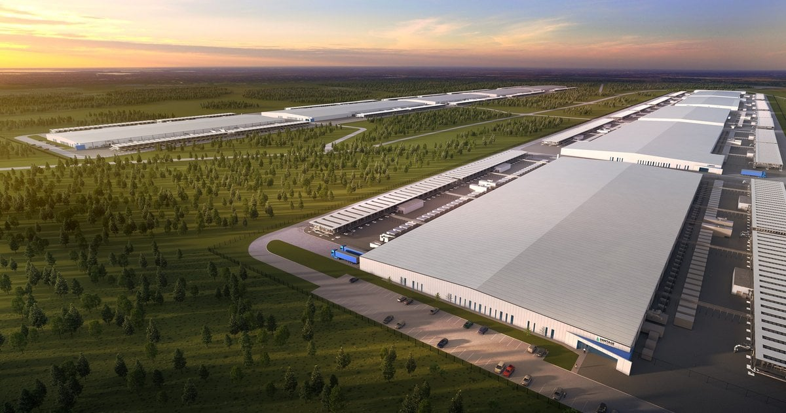

Figure #3: $25 Billion Data Center in Texas

Environmental Impacts Associated with AI

Energy Consumption & Carbon Emissions

Training large-scale models requires thousands of GPUs running continuously for weeks or even months, consuming massive amounts of energy. AI models need frequent retraining and constant interference operations, leading to the reliance on non-renewable energy sources in many regions. A ChatGPT request requires nearly 10 times more electricity than a standard Google search. In fact, as of 2024, global data centers consumed around 412 TWh of electricity, which was around 1.5% of the worldwide power demand. What’s alarming is that with the explosive demand of AI, electricity use is projected to quadruple by 2030. Some of the larger AI data centers under construction could even consume as much electricity as 2 million households. These tremendous consumptions of energy have absolutely detrimental effects on the environment. In 2025, researchers estimate that AI systems may have produced up to 80 million tons of CO2, which is the equivalent to air pollution of the entirety of New York City.

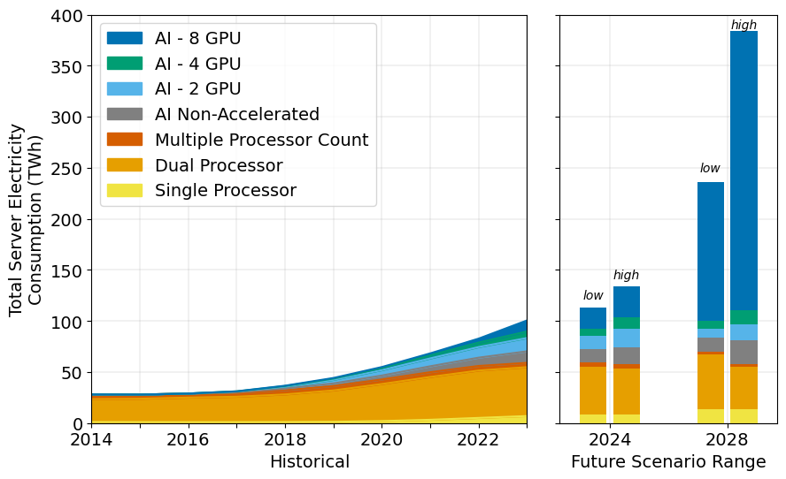

Figure #4: Total Annual Server Energy Use Accelerated by AI (Shehabi, et al., 2024)

Water Usage

Many data centers also require water-based cooling systems to prevent systems from overheating. In warm or water-scarce regions, freshwater consumption is common, and competition between industrial water use and local community needs is tensioned. In fact, a 2025 study found that AI systems and data centers consumed about 765 billion liters of water, surpassing global bottled water use. According to a Morgan Stanley report, by 2028, annual water use for cooling and electricity generation in data centers could reach about 1,068 billion liters- roughly 11 times higher than 2024 levels. The demand for water has worsened to the point where individual hyperscale data centers use around 1.4 million liters of water per day for cooling. To put it in perspective, every 100-word AI prompt can use around 1 bottle of water. However, it’s also important to note that many researchers and scientists believe that the AI water problem is not as significant as many might think. While these systems do waste water, they are considerably small in comparison to other daily activities.

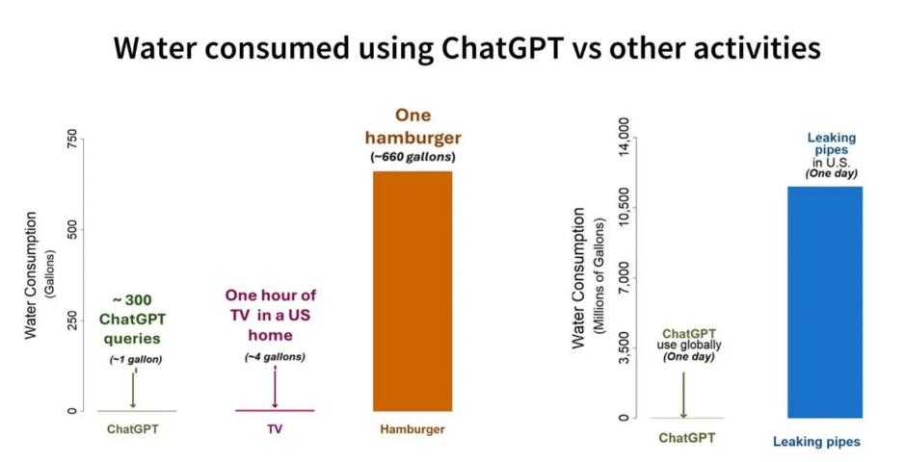

Figure #5: Comparisons of Water Usage by ChatGPT (Li, et al., 2023; Liemberger & Wyatt, 2020)

Electronic Waste

Due to the short life cycles of AI hardware, such as servers, GPUs, or processors, the disposal of outdates or inefficient equipment leads to improper e-waste recycling and disposal, producing around 2,500 tons of e-waste per year. This number could jump to 2.5 million tons annually by 2030, and AI e-waste could contribute to 12% of global e-waste by that time frame. Moreover, AI-related waste contains toxic metals and chemicals such as lead, mercury, or chromium that can harm soil and water if improperly disposed of. Due to the rare earth minerals used in AI chips, these forms of waste could contain hundreds of thousands of tons of hazardous substances, leading to environmental contamination and health risks.

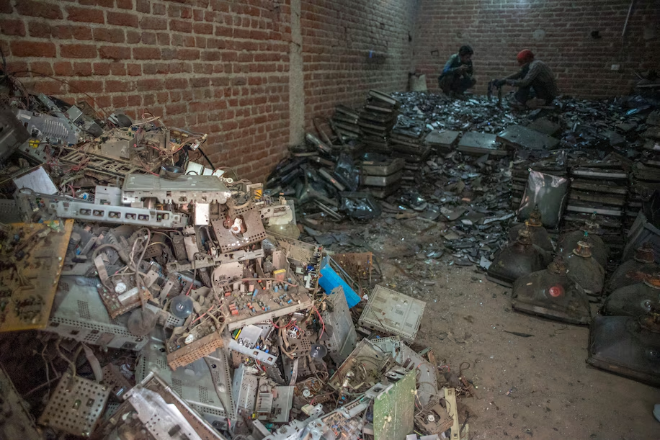

Figure #6: Disassembled Discarded Computer Monitor Systems Near an E-Waste Workshop in New Delhi, India

Major Parties Involved

United States
The United States currently hosts many of the world’s largest AI developers and cloud service providers. With booming tech hubs in Silicon Valley, major financial powerhouses in cities like New York or San Francisco, and a relatively free legal environment that protects intellectual property while encouraging innovation, the US is home to extensive data center infrastructure with high energy and water demands. While domestic debate over data center regulation and resource use emissions have grown heated in recent years, America still nonetheless plays a major role in shaping global norms and trend for AI development and sustainability. In fact, American tech giant Nvidia has been a game changer in the AI race with China for the US. The company’s top AI chips control the global growth of AI, and as legislation and political movements shift, these actions decide the amount of Nvidia’s chips exported and sold to China. The US seems to be pushing towards artificial general intelligence, investing extraordinary numbers into building computer systems that could equal or surpass human cognition. However, this stance does not seem to be shared across the globe.

China
As the other main competitor in the AI race against the US, China has taken a slightly different approach with artificial intelligence. Instead of pouring all resources into building the best AI model, the Chinese government has shifted to smooth and proper integration of AI into public systems and also into the daily lives of Chinese citizens. State-led investment in artificial intelligence and high-performance computing has led to the rapid expansion of data centers and AII hardware manufacturing facilities. Yet, China has also ensured AI fluency through education systems in secondary education while integrating AI into Chinese employee life. Although environmental impacts of AI growth have been exacerbated by energy-intensive infrastructure and regional water scarcity, China focuses on technological self-sufficiency, deploying AI to build the most powerful economy.

European Union
Unlike the US or China, the European Union has remained adamant in their dedication to creating a regulated but beneficial AI market. The European Parliament’s priority is making sure that AI systems in the EU are safe, transparent, traceable, non-discriminatory, and most importantly, environmentally friendly. The EU believes that AI should be overseen by people, not automation. Parliament sees the many potential benefits and advancements that AI can bring, such as better healthcare, safer and cleaner transport, more efficient manufacturing, and cheaper sustainable energy. Yet, they also recognize the potential harms that AI may bring, including those related to the environment.

Microsoft
Microsoft is one of the world’s leading developers in AI technologies and cloud computing services, investing over $80 billion into artificial intelligence this fiscal year alone. With an expanding global data center network, Microsoft has seen an increase in carbon emissions of nearly 30% since 2020. However, the company has claimed that it will be carbon negative by 2030, aiming to improve environmental impacts of their technology while promoting water-positive initiatives. Thus, Microsoft has taken on a multitude of approaches to combat their large carbon footprint, with some of the more notable ones being novel construction methods. Microsoft has begun to switch their data center construction materials to wood, using cross-laminated timber (CLT) that is ultra-lightweight while also benefitting from fire resistance. These new materials have a projected 35% lower carbon footprint when compared to regular steel construction and a 65% drop when compared to precast concrete.

Google
Google, in contrast, has taken a less environmentally approach with AI. Despite having the goal of reaching net-zero emissions by 2030, Google has begun to write in their sustainability reports starting from 2023 that it was no longer “maintaining operational carbon neutrality”. The company believes that their purpose is to build the best AI systems they can, meaning that they’re willing to train AI systems on bigger and bigger data centers, consuming a tremendous amount of electricity and producing unmatched CO₂ emissions. Regardless of their scrutiny over water usage and regional environmental impacts, Google has maintained their role as a leader in AI research and large-scale data center operations.

Timeline of Events
Date | Event Name | Description
June 1956 | Dartmouth Summer Research Project on Artificial Intelligence | The first formal academic conference on artificial intelligence, often seen as the “birth” of AI. Marks AI as a field of study and viewed as the starting point of long-term computational development.
December 2015 | Adoption of Paris Agreement | Marked the first time governments jointly agreed on a major collective effort to limit global warming and it’s impacts at an international conference.
June 2020 | UN Secretary-General Roadmap for Digital Cooperation Launch | Formally brough digital sustainability and responsibility into the development frameworks and policies under the UN in the international community.
February 2021 | UNEP Expands Focus to Digital Environmental Impacts | The UNEP begins to explicitly integrate digitalization and computing infrastructure in environmental sustainability assessments, marking a win for environmental activists.
November 2022 | OpenAI Released ChatGPT to the Public | Served as an explosive launch of artificial intelligence to the public eye and use, integrating AI into daily lives instead of technical or professional work.
June 2024 | EU Adopts the Artificial Intelligence Act | The European Union passes the world’s first rules on AI, creating and implementing the first comprehensive framework on AI.
Present Day | The AI Bubble | Today, AI has advanced to the point where humans are stuck between a collision of scientific uncertainty and evolving business thinking. The AI bubble might burst, meaning that an overinvestment in AI can potentially lead to company collapse and job loss.

Previous Attempts to Solve the Issue
Numerous big tech companies have started their own eco-friendly campaigns under the public eye to mitigate the environmental effects of their products. Companies like Google, Microsoft, and Amazon Web Services have invested in large-scale renewable energy procurement. These tech giants have spent billions on combining solar energy, wind energy, energy storage, and strategic geographic distribution to ensure a steady supply of renewable energy. Top corporations have even turned to hydrogen and nuclear and energy for AI data centers. Certain startups and companies have built hydrogen-powered data centers, while others have started to restart nuclear reactors near data centers to provide nuclear energy.
In some states, government intervention has forced tech companies to adopt environmentally friendly policies for data centers nod high-performance computing facilities. The European Union and several individual states have implemental regulations requiring improved energy efficiency, reporting standards, and emissions reductions for large computing infrastructure. However, while these regulations have encouraged the adoption of efficient cooling systems and hardware in certain data centers, these policies are still very limited in global reach and enforcement, lacking in international coordination and compliance.
Other research institutions and corporations have also started to pour resources into developing energy-efficient AI models and hardware, striving for technological innovation and advancement. In fact, efforts such as optimizing machine-learning algorithms, reducing training cycles, and developing specialized AI chips have aimed to decrease the computational and energy demands of AI systems. For example, Chinese developers have come out with DeepSeek in January of 2025, a new AI model that doesn’t rely on Nvidia chips while producing a fraction of the waste. Although many of these new inventions are still in development, these advancements do improve efficiency, and with further investment and research, may serve as a game changer in global AI development.

Relevant UN Treaties and Events
- Paris Agreement, 2015 (FCCC/CP/2015/10/Add.1)
- 2030 Agenda for Sustainable Development, 2015 (A/RES/70/1)
- UN Environment Programme Digital Sustainability Initiatives
- UN Secretary-General’s Roadmap for Digital Cooperation, 2020
- UN Framework Convention on Climate Change (UNFCCC), 1992

Possible Solutions
One possible solution would be the creation of international, globalized standards for sustainable AI use. Since some countries view the environmental impacts of AI less seriously than others, developing an internationally agreed-upon environmental standard can govern AI deployment properly. Some requirements under this comprehensive framework could include efficiency benchmarks for AI model training and operation, limiting the excessive usage of AI. This means that developers would prioritize efficiency when creating new AI models, discouraging unnecessary large-scale training runs. Another requirement could be mandatory reporting systems for energy consumption, water usage, and carbon emissions associated with data centers. This would hold countries and companies accountable, improving transparency and communication in the international community. Additionally, cross-country comparisons would be made easier with standardized UN-backed metrics, making it easy to identify which countries and companies are failing in their environmental duties.
Another solution that delegates could opt for would be integrating environmental impact assessments (EIAs) into large-scale AI infrastructure projects. This would be an extension of life-cycle assessments (LCAs) in product analysis, making companies re-evaluate the environmental impacts across the full lifespan of their AI systems, including hardware production, operation, and disposal. EIAs would focus on the impacts of local energy grids, water resources, land use, and surrounding ecosystems. Governments would be able to view these assessments before approving new, hyperscale data centers or AI research facilities.
Supporting technology transfer is another resolution that delegates could focus on. Currently, many big tech corporations like Google tend to have their priorities focused on creating AI models over all other objectives, including environmental and carbon emission goals that the companies set themselves. Hence, incentives could be provided to support the development and adoption of low-resource, sustainable AI infrastructure. Examples of this could include international cooperation in sharing energy-efficient AI technologies, cooling systems and infrastructure designs. Another important aspect of this solution would be budgeting, where financial and technical assistance could be provided to states that are seeking to deploy sustainable AI systems. With these incentives, both companies and countries would be more inclined to step towards an eco-friendlier future.

Bibliography

Adamec, Václav. “A Brief History of AI and the Rise of ChatGPT.” GaussAlgo, 23 July 2024, www.gaussalgo.com/knowledge-base/a-brief-history-of-ai-and-the-rise-of-chatgpt.

Admin, and Admin. “Water Usage in Cooling Towers Explained.” Pinnacle Cooling Tower Service, 7 Nov. 2024, pinnaclects.com/water-usage-in-cooling-towers.

Allen, Kieron. “Microsoft Addresses Environmental Impact of Data Centers With Novel Construction Methods.” Cloud Wars, 22 Nov. 2024, cloudwars.com/innovation-leadership/microsoft-addresses-environmental-impact-of-data-centers-with-novel-construction-methods.

“America’s AI Strategy: Playing Defense While China Plays to Win.” Wilson Center, 24 Jan. 2025, www.wilsoncenter.org/article/americas-ai-strategy-playing-defense-while-china-plays-win?gad_source=1&gad_campaignid=20397340047&gbraid=0AAAAAD3FqOM-PL-kVviTNjo_ZCMsmYhco&gclid=EAIaIQobChMI_NGxnObNkQMVDopQBh3y5DABEAAYBCAAEgLf5PD_BwE.

Booth, Robert. “AI Boom Has Caused Same CO2 Emissions in 2025 as New York City, Report Claims.” The Guardian, 18 Dec. 2025, www.theguardian.com/technology/2025/dec/18/2025-ai-boom-huge-co2-emissions-use-water-research-finds.

Booth, Robert. “AI Boom Has Caused Same CO2 Emissions in 2025 as New York City, Report Claims.” The Guardian, 18 Dec. 2025, www.theguardian.com/technology/2025/dec/18/2025-ai-boom-huge-co2-emissions-use-water-research-finds.

Chris. “E-Waste | Meaning, Recycling, and Disposal Procedures.” Computer Aid, 14 Aug. 2025, www.computeraid.org/blog/e-waste-meaning-recycling-and-disposal-procedures/?gad_source=1&gad_campaignid=22029508231&gbraid=0AAAAAD8NcpV37Sgrg-yF6G4-BGtPyRnWm&gclid=EAIaIQobChMIjc2dhtfNkQMV9QVECB1agQNDEAAYASAAEgLOkfD_BwE.

Computer History Museum. “The 1956 Dartmouth Workshop and Its Immediate Consequences: The Origins of Artificial Intelligence - CHM.” CHM, 1 Aug. 2019, computerhistory.org/events/1956-dartmouth-workshop-its-immediate.

De Hoop Scheffer – Senior Director Data Center Energy Lead, William. “Renewable Energy for AI Data Centers: A Complete Guide.” Hanwha Data Centers, 25 Nov. 2025, www.hanwhadatacenters.com/blog/renewable-energy-for-ai-data-centers-a-complete-guide.

“EU AI Act: First Regulation on Artificial Intelligence | Topics | European Parliament.” Topics | European Parliament, 6 Aug. 2023, www.europarl.europa.eu/topics/en/article/20230601STO93804/eu-ai-act-first-regulation-on-artificial-intelligence.

“Explained: Generative AI’s Environmental Impact.” MIT News | Massachusetts Institute of Technology, 17 Jan. 2025, news.mit.edu/2025/explained-generative-ai-environmental-impact-0117.

Gordon, Cindy. “AI Is Accelerating the Loss of Our Scarcest Natural Resource: Water.” Forbes, 7 Mar. 2024, www.forbes.com/sites/cindygordon/2024/02/25/ai-is-accelerating-the-loss-of-our-scarcest-natural-resource-water.

“How Bad Are AI Data Centres’ Carbon Footprint?” Euronews, 20 Dec. 2025, www.euronews.com/next/2025/12/20/ai-data-centres-could-have-a-carbon-footprint-that-matches-small-european-country-new-stud.

Islam, Faisal, and Rachel Clun. “Google Boss Says Trillion-dollar AI Investment Boom Has ‘elements of Irrationality.’” BBC News, 18 Nov. 2025, www.bbc.co.uk/news/articles/cwy7vrd8k4eo.

Kerr, Dara. “AI Brings Soaring Emissions for Google and Microsoft, a Major Contributor to Climate Change.” NPR, 12 July 2024, www.npr.org/2024/07/12/g-s1-9545/ai-brings-soaring-emissions-for-google-and-microsoft-a-major-contributor-to-climate-change.

Kirvan, Paul. “What Is Green Computing?” Search Data Center, 31 July 2024, www.techtarget.com/searchdatacenter/definition/green-computing.

“Life Cycle Assessment.” European Environment Agency, www.eea.europa.eu/help/glossary/eea-glossary/life-cycle-assessment.

Martin. “The Sustainable Development Goals - United Nations Sustainable Development.” United Nations Sustainable Development, 12 Aug. 2025, www.un.org/sustainabledevelopment/development-goals.

Morata, Loize Angel. “How Does AI Affect E-waste in 2025 — Torres Marketing.” Torres Marketing, 6 Aug. 2025, www.torresmarketinginc.com/blog/how-does-ai-affect-e-waste-in-2025.

Novet, Jordan. “Top Tech Companies Turn to Hydrogen and Nuclear Energy for AI Data Centers.” CNBC, 24 Feb. 2025, www.cnbc.com/2025/02/24/big-tech-companies-turn-to-hydrogen-to-power-ai-data-centers.html.

O’Donnell, James. “We Did the Math on AI’s Energy Footprint. Here’s the Story You Haven’t Heard.” MIT Technology Review, 22 Sept. 2025, www.technologyreview.com/2025/05/20/1116327/ai-energy-usage-climate-footprint-big-tech.

“Paris Agreement on Climate Change.” Consilium, www.consilium.europa.eu/en/policies/paris-agreement-climate.

Portulansinstg. “The UNSG Roadmap for Digital Cooperation.” Portulans Institute, 18 June 2020, portulansinstitute.org/unsg-roadmap-for-digital-cooperation.

Proofpoint. “What Is a Data Center? Definition and Types | Proofpoint US.” Proofpoint, 3 Jan. 2025, www.proofpoint.com/us/threat-reference/data-center.

Schmidt, Eric. “How The U.S. Can Win the AI Race.” TIME, 11 Dec. 2025, time.com/7339638/eric-schmidt-ai.

Seth, Shobhit. “Why Silicon Valley Is Ideal for Tech Startups.” Investopedia, 4 Dec. 2025, www.investopedia.com/articles/personal-finance/061115/why-silicon-valley-startup-heaven.asp.

Shahid. “History of Data Centers: Milestones in Innovation and Expansion.” DartPoints, 21 July 2025, dartpoints.com/blog/history-of-data-centers.

Staff, Coursera. “The History of AI: A Timeline of Artificial Intelligence.” Coursera, 15 Oct. 2025, www.coursera.org/articles/history-of-ai.

The Hidden Cost of AI: A Looming E-Waste Crisis by 2030 – AI2MED. www.ai2med.eu/the-hidden-cost-of-ai-a-looming-e-waste-crisis-by-2030.

UNTERM - Artificial Intelligence. unterm.un.org/unterm2/en/view/49e80eb5-7736-4861-8f62-ffacfde67208.

United Nations Division for Sustainable Development-National Information-Indicators of Sustainable Development. www.un.org/esa/sustdev/natlinfo/indicators/indisd/english/chapt4e.htm.

Walsh, Shelley. “Timeline of ChatGPT Updates & Key Events.” Search Engine Journal, 20 Oct. 2025, www.searchenginejournal.com/history-of-chatgpt-timeline/488370.

“What Is a Carbon Footprint? | Conservation International.” Conservation International, www.conservation.org/learning/what-is-a-carbon-footprint.

“What Is the History of Artificial Intelligence (AI)?” Tableau, www.tableau.com/data-insights/ai/history.

“Why AI Uses so Much Energy — and What We Can Do About It.” Institute of Energy and the Environment, 8 Apr. 2025, iee.psu.edu/news/blog/why-ai-uses-so-much-energy-and-what-we-can-do-about-it.

