Forum: Human Rights Committee (HRC)
Issue: Protecting the right to education in conflict zones
Student Officer: Marcus Perez
Position: President

Introduction
Classrooms are becoming more common sites in battlefields. Classrooms that should have been sanctuary for learning are now sites of horror, confusion, and loss created by conflict. Protecting the right to education during armed conflicts is not only an ethical duty but a strategic obligation as well because it is what gives generations the tools to rebuild the World rather than being trapped in violence and poverty. International laws state that every child has the right to receive a quality education, even during wartime; however, current circumstances in which we live in reflect completely different outcomes. Millions of students see their schools attacked, militarized, or shut down, often overnight.
UNICEF's estimates show that in 22 conflict-affected countries, over 25 million children aged 6 to have already dropped out of school. More recently, estimates show that there will be an additional 103 million school aged children did not attend school during the 2024 within conflict and fragile states. Children who live in a violent environment are disproportionately more likely to lack basic literacy and numeracy skills compared to their peers living in stable environments, due to being directly exposed to the increased risk of being recruited into child labour, marrying early, or getting involved with armed groups. Each additional year of school missed on behalf of these children ultimately weakens the countries, and our collective, pool of human capital while also hindering long-term peace and development.
Attacks on education take many forms and rarely end with damaged buildings. Schools may be bombed or shelled, teachers threatened or killed, and students harassed or abducted on their way to class. Armed forces and non-state groups sometimes occupy schools as bases, ammunition depots, or barracks, turning them into military targets and forcing families to choose between their children’s safety and their right to learn. When classrooms close or are perceived as unsafe, children—especially girls—are pushed toward harmful coping mechanisms, including early marriage, exploitative work, and dangerous migration.
​
Yet education in conflict is far more than the transfer of academic knowledge; it is also a crucial form of protection and a bridge to peace. Regular schooling provides structure, psychosocial support, and a sense of normalcy in the midst of chaos, helping children process trauma and maintain hope for the future. Studies and field experience show that safe learning environments reduce the likelihood that youth will be drawn into armed groups or criminal networks, and that inclusive, conflict-sensitive curricula can counter hate narratives and foster dialogue. As a result, education is increasingly recognised in global forums as a lifesaving intervention on par with food, water, and shelter.

Definition of Key Terms

Attacks on Education
Violence aimed at students, teachers, educators, educational institutions and transportation used to travel to those institutions, or anything associated with education constitutes an Attack on Education. UN Monitoring Frameworks recognize the following deliberate or indiscriminate acts of violence that fall within the definition of an Attack on Education: bombings, shelling, shootings, kidnappings or hostage-taking, threats of individuals, looting, and other acts that violate the provisions contained in the Children and Armed Conflict agenda. The number of these attacks has increased world-wide since 2022, when more than 11,000 attacks were recorded within a 12-month period in Ukraine, Palestine, and Sudan, resulting in Schools, which are clearly marked as civilian objects, being deliberately attacked, thereby preventing millions of children from receiving an education and enforcing the continuation of the cycle of poverty and instability associated with the lack of education.

Education in Emergencies
Education in emergencies refers to organized, safe, quality learning interventions delivered from crisis onset—whether conflict, displacement, or disaster—for affected children and youth, prioritizing psychosocial support, literacy/numeracy catch-up, and skills for resilience via temporary spaces, radio/digital platforms, or accelerated curricula. Guided by the INEE Minimum Standards, it addresses the fact that over 224 million crisis-affected children lack schooling, aiming to mitigate trauma, curb child labor/recruitment, and uphold the INEE Charter's assertion that education is a first responder right alongside water and food.
International Humanitarian Law
In armed conflict situations, international humanitarian law is guided by four Geneva Conventions adopted in 1949 and their additional protocols. This law ensures the separation of civilian from military targets, while also providing protection for civilian objects (e.g. schools) from damage due to warfare unless utilized for military purposes. Article 50 of the First Protocol and customary law legally obligates occupying authorities to ensure that occupied children receive an education, prohibits reprisals against educational institutions, and holds violators accountable as war criminals. However, enforcement is becoming increasingly difficult as a result of modern warfare, especially when the combatants are non-state actors engaging in asymmetric warfare.

Grave Violations Against Children
UN Security Council Resolution 1612 (and related later Resolutions) defines grave violations against children in armed conflict through six categories: killing or maiming; recruitment of children into armed forces/groups; rape or sexual violence; abduction; attacks on schools and hospitals; denial of humanitarian access. Education-related abuses are the main concern of the global Monitoring and Reporting Mechanism. In the 2024-2025 reports, there are still many thousands of these incidents continuing in Yemen, Sudan, and the DRC. This continual use of child soldiers was enough to prompt listing these perpetrators on the UN's "name and shame" list, as well as Security Council engaging in sanctions against them, along with plans of action designed to ensure compliance. These findings emphasize the importance of education as a tool for both preventing recruitment and promoting peace.

Military use of schools
Schools are utilized by militaries or non-state actors as military bases, barracks, caches of weapons, sites to detain people and firing positions. By using education facilities as military objectives, schools become targets and are susceptible to attack in accordance with International Humanitarian Law. The military use of schools is prohibited by international guidelines, such as the UN's 2014 Lucens Guidelines. The military use of more than 1,000 schools worldwide resulted in their closure due to significant risks to children's safety, as well as hindering the psychological recovery of children and communities.

Psychosocial support in schools

Services and activities—such as counseling, social-emotional learning, and safe routines—delivered through education to help children cope with trauma and stress caused by conflict.​

History & Developments

Early recognition of education war

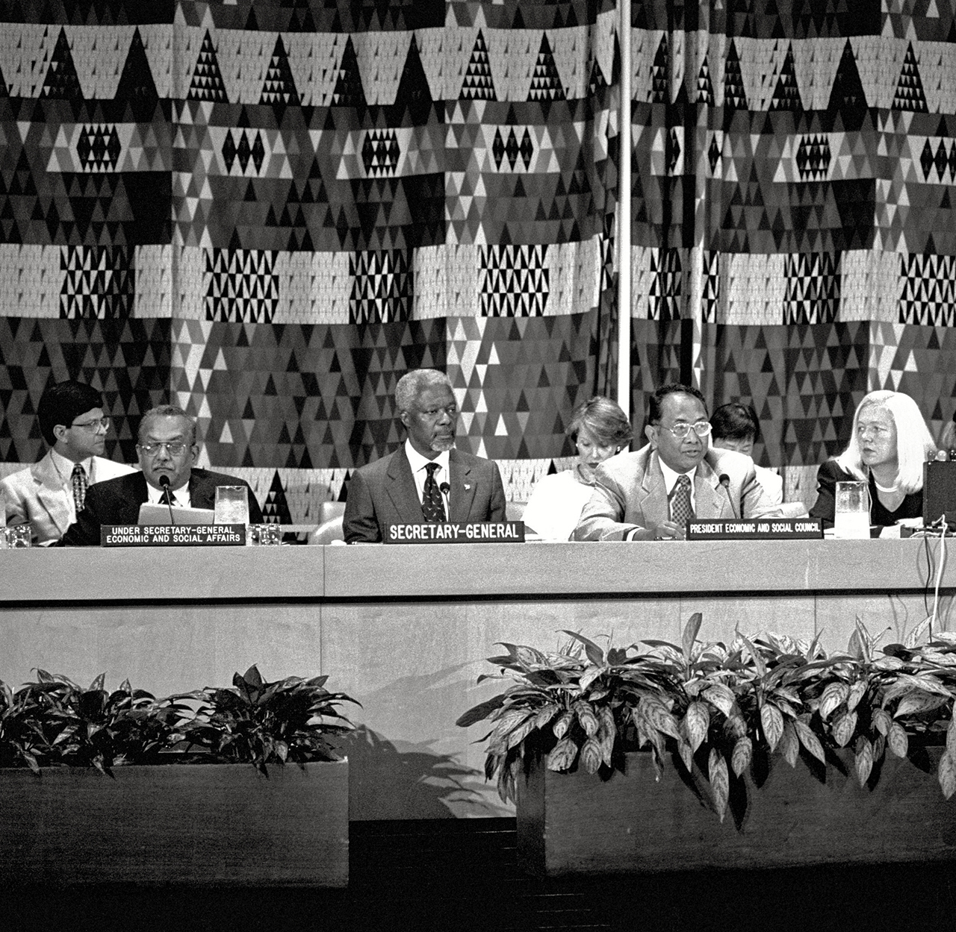

Figure #1: Meeting on the International Covenant on Economic, Social, and Cultural rights
Throughout the twentieth century, the international community gradually acknowledged that education must not simply be paused during conflict but actively safeguarded as a right. The Universal Declaration of Human Rights (1948) affirmed education as a fundamental human right for all, setting a normative baseline that applies “without limitation” even in times of crisis. This was reinforced by the International Covenant on Economic, Social and Cultural Rights (ICESCR, 1966), which requires states to make primary education compulsory and free, and to progressively realize higher levels of education to the maximum of available resources, a duty that does not disappear because a country is at war.
At the same time, international humanitarian law (IHL) began to frame how education infrastructure and children should be treated in armed conflict. The 1949 Geneva Conventions and their 1977 Additional Protocols codified rules protecting civilians and civilian objects, including schools, from intentional attack and requiring parties to facilitate education in occupied territories. Under these rules, schools are presumed to be civilian objects and may not be targeted unless used for military purposes, establishing a legal foundation that later debates on “military use of schools” would build upon.

Emergence of child specific protection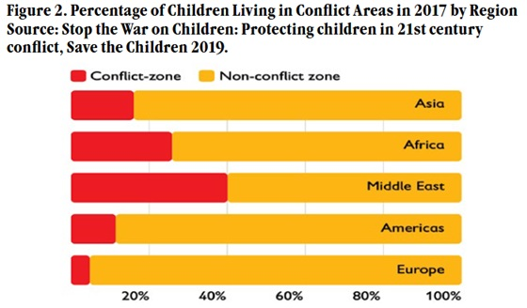

Figure #1: Chart detailing percentage of children living in conflict areas

In the later years of the 20th century, the focus shifted to child/family-friendly policies due to growing recognition that violence impedes child education. The Convention on the Rights of the Child (CRC, 1989) recognized children's rights to education and required governments to take all reasonable measures to shield children from military-related impacts on all aspects of life, including education. Shortly thereafter, the Optional Protocol to the Convention on the Rights of the Child on the Participation of Children in Armed Conflict (2000) began to directly address child recruitment, much of which took place on or near school property, and required states not to use educational facilities as recruitment sources.

In 1999, the UN Security Council (UNSC) initiated the Children and Armed Conflict (CAC) initiative by passing Resolution 1261, which marked a precedent as it represented the first time the Security Council recognized that acts committed against children, including those affecting their ability to learn, constituted a threat to regional and global peace and security. This resulted in the establishment of the Monitoring and Reporting Mechanism (MRM) under UNSC Resolution 1612 (2005), which is responsible for tracking six of the most serious violations of children's rights, including attacks on schools and hospitals. As the MRM developed through the years, it was able to help transform anecdotal evidence of attacks against education into systematically documented evidence of war crimes, although there continues to be inadequate accountability for these violations.

Education as an emergency response
By the early 2000s, practitioners and researchers increasingly argued that education in conflict must be treated as a lifesaving intervention, not a secondary development goal. The Inter-Agency Network for Education in Emergencies (INEE), established in 2000, developed Minimum Standards that framed education as a core part of humanitarian response, emphasizing safe learning environments, psychosocial support, and community participation. These standards helped define what quality education in emergencies should look like .
At the multilateral level, the UN General Assembly adopted Resolution 64/290 on “The right to education in emergency situations” in 2010, explicitly stating that the right to education applies during armed conflict and disasters and calling on states and donors to ensure safe, inclusive, and quality learning opportunities in crises. This resolution signaled a growing consensus that schooling in conflict settings is essential for protection, social cohesion, and future recovery, though it stopped short of creating binding enforcement mechanisms.

New political commitments
The Safe Schools Declaration was an important milestone in the history of the campaign against attacks on education in times of armed conflict. Governments from around the world made a political commitment to protect schools and universities from attack and occupation by military forces, to refrain from using them for military purposes, and to collect data on attacks. Although the Declaration has no legal force, it is associated with the Guidelines to Protect Schools and Universities from Military Use during Conflict, and has influenced some legal and policy changes within countries, such as making school occupation a criminal act and changing military manuals.

At the same time, long-standing underfunding of education in crisis situations resulted in the establishment of dedicated sources of financing. In 2016, Education Cannot Wait (ECW) was established as the first global Fund dedicated exclusively to the provision of education during emergencies and protracted crises. The intent was to bridge the gap between response to humanitarian crises and long-term improvement of education systems. Education Cannot Wait and similar initiatives have been working towards increasing the share of humanitarian funding allocated to education. However, despite these efforts, funding still remains inadequate compared to the millions of children who continue to be out of school due to conflict.

Rising global attention and continuing challenges
Human Rights Watch, GCPEA, and UNICEF have reported an increase in attacks on educational facilities in a variety of contexts, such as Ukraine, Sudan, Palestine, and parts of the Sahel, as evidenced by large numbers of school buildings being bombed, occupied or destroyed on a massive scale. One-third of all children affected by conflict and fragility are no longer enrolled in school. Additionally, more than 25 million children living in conflict-affected areas do not have access to education at all, meaning that the various political proclamations, financial mechanisms, and legal standards that currently exist for protecting education rights have yet to provide effective protection over time. Delegates attending the conference will need to consider how to transform these normative commitments into enforceable, practical protections for education rights in conflict-affected areas.

Major Parties Involved

Conflict affected states (e.g., Afghanistan, Ukraine, Yemen)
Governments of conflict-affected states are both duty-bearers and, at times, alleged violators in this issue. Their stated interests include preserving national education systems, maintaining control over curricula, and demonstrating compliance with international obligations, but they may also prioritize security objectives that lead to closure or militarization of schools. Many of these states are parties to key treaties such as the Convention on the Rights of the Child and ICESCR, and some have endorsed the Safe Schools Declaration, aligning them with coalitions focused on preventing attacks and military use of schools. Relations with UN agencies and NGOs can be collaborative when external actors provide funding and technical support, yet tensions arise when international monitoring highlights government forces’ responsibility for violations or when sovereignty concerns are invoked to limit access for humanitarian education actors.
​

United Nations (Including UNICEF and UNESCO)
The United Nations system including UNICEF and UNESCO, the Office of the High Commissioner for Human Rights (OHCHR), and the Special Representative for Children and Armed Conflict all serve important roles within its framework of establishing, monitoring, and programming child protection laws. In its work to uphold the principles of International Human Rights Laws the UN's primary focus is to facilitate access to safe, high-quality educational opportunities for all children affected by war or displacement. The UN also provides support and encourages the formation of coalitions including Nations , NGOs, and international organizations that share a common goal under the Children and Armed Conflict (CAAC) agenda; provide support through the Education Cannot Wait (ECW) fund; and develop platforms for global collaborative efforts in Education in Emergencies. Working with member states can be collaborative, such as through technical assistance and funding, and through practical cooperation; however, they can also create hostility if UN monitoring and reporting threatens sovereignty of governments and/or armed groups in attacks against schools or military use of educational facilities.

Major donor states
High-income donor states are crucial financiers of education in emergencies and champions of global initiatives such as Education Cannot Wait and the Safe Schools Declaration. Their interests include promoting global stability, preventing forced migration, advancing human rights, and projecting soft power through development assistance and leadership in multilateral forums. Many donor countries are active in coalitions like the Global Partnership for Education, the INEE (Inter-Agency Network for Education in Emergencies), and the Safe Schools Declaration support group, where they coordinate funding priorities and policy standards. Relations with conflict-affected states and NGOs are generally cooperative but sometimes politically conditional, as donors may tie education funding to governance reforms or human rights performance, and geopolitical rivalries can influence where and how funds are allocated.​
Non-state Armed Groups
Although non-state armed groups (e.g., insurgent groups, militia groups, terrorist organizations) have been key participants in attacks on education, recruitment of children from schools, and military occupation of educational institutions, their actions have differed in intent. Some groups will occupy school facilities to attain strategic advantages (i.e., "control"), while other groups are most interested in controlling curriculum and promoting ideological indoctrination. Unlike state actors, these groups have no formal relationship with any international organizations, although they can be considered to be "indirectly" involved with the activities of the UN through the action plan process described in the CAAC, in which groups agree to cease their violations against children in exchange for de-listing or improved standing within the international community. Relations with states, UN bodies, and NGOs are highly context-dependent—ranging from hostile confrontation to pragmatic engagement—making them critical yet challenging counterparts in any effort to protect education in conflict zones.​ Content

International and Local NGOs (Save the Children, War Child, Plan International, NRC)
International and local non-governmental organizations provide frontline education services, advocacy, and monitoring in conflict settings. Their interests center on safeguarding children’s rights, delivering safe learning opportunities, and influencing policy by documenting attacks on schools and highlighting funding gaps for education in emergencies. Many NGOs are key members of coalitions such as the Global Coalition to Protect Education from Attack (GCPEA), the INEE network, and country-level education clusters coordinated with the UN, where they help set standards and share data. They collaborate closely with UN agencies and donors while sometimes challenging both states and armed groups through public campaigns and reports, which can strain relations but also drive policy change and accountability.
​

Timeline of Events
Date | Event Name | Description
December 10 1948 | Adoption of the Universal Declaration of Human Rights (UDHR) | UDHR Article 26 recognizes education as a fundamental human right for everyone, creating the baseline principle that applies even when states face instability or conflict.​
November 20, 1959 | UN Declaration of the Rights of the Child | The General Assembly declaration affirms children’s rights to education and special protection, helping shape later binding instruments on children affected by armed conflict.​
June 9, 1998 | Rome Statute of the International Criminal Court | The Rome Statute classifies intentional attacks on buildings dedicated to education as potential war crimes when they are not military objectives, creating a direct accountability link between attacks on schools and international criminal law.​
August 11, 2000 | Creation of the UN “Children and Armed Conflict” Agenda | The UN Security Council formally establishes the children and armed conflict (CAAC) agenda, mandating systematic monitoring of grave violations against children, including attacks on schools and hospitals.​
July 19, 2011 | UN Resolution on the Right to Education in Armed Conflict Areas | The UN adopts a resolution highlighting that more than 28 million out-of-school children live in conflict-affected countries, condemning targeted attacks on schools, teachers, and students, and urging measures to protect education in war.​
May 2015 | Launch of the Safe Schools Declaration in Oslo | States endorse the Safe Schools Declaration, committing to protect students, teachers, and educational institutions during armed conflict, discourage military use of schools, and collect data on attacks, marking a major soft-law milestone.  ​
2011–2019 (no specific day) | Escalating Attacks in Syria, Yemen, and Sahel Conflicts | Protracted wars in Syria and Yemen, along with insurgencies in countries such as Nigeria and Mali, lead to widespread school bombings, abductions of students and teachers, and long-term closures, pushing education in emergencies onto the global humanitarian agenda.​
February 24, 2022 | Full-Scale Russian Invasion of Ukraine and School Attacks | The escalation of war in Ukraine leads to widespread damage and destruction of schools through shelling, airstrikes, and drone attacks, with hundreds of education facilities recorded as attacked or occupied over 2022–2023.​
August 11, 2022 | Global Reporting on War’s Impact on Learning | New global analyses highlight that children in conflict-affected countries are significantly less likely to complete primary school and that only about half of refugee children are enrolled in education, emphasizing the long-term human capital cost of conflicts.​
April 2023 | Outbreak of Conflict in Sudan and Education Collapse | Fighting that erupts in Sudan forces the closure of most schools, leaving more than three-quarters of the country’s 17 million school-age children out of education, and raising alarm over a “lost generation.”​
October 23, 2025 | UN Policy Brief on Education in Armed Conflict | The UN Special Rapporteur on the right to education presents a policy brief identifying education as a “lifeline” during armed conflict and recommending concrete state actions, including preventing military use of schools, ensuring continuity of learning, and strengthening accountability for attacks on education.​

Previous Attempts to Solve the Issue
One major attempt was the launch of the Safe Schools Declaration in May 2015, an intergovernmental political commitment led by Norway and Argentina that invites states to endorse a set of principles to protect students, teachers, schools, and universities during armed conflict. Endorsing states agree to use the Guidelines for Protecting Schools and Universities from Military Use During Armed Conflict, to review and adapt their national laws, policies, and military doctrine, and to report on measures taken, with over 120 countries now participating and some,such as the Central African Republic,criminalizing military use of schools as a result.

In response to the growing demand for education access, the creation of the education cannot wait (ECW) Global Fund in 2016 was a significant step toward providing greater access to education in times of crisis by harnessing the collective resources of governments and UN Agencies as well as private entities to enable rapid, multi-year responses on behalf of children who experienced school disruptions due to armed conflict or natural disasters. ECW works with a unique funding model that focuses on encouraging political action; building partnerships between NGOs and developing countries; and closing existing funding gaps. ECW currently supports countries including Syria, Yemen, and the Sahel, however, ECW is responding to much greater needs than its current capabilities.
The **African Union’s Peace and Security Council and the Continental Education Strategy for Africa (CESA 2026–2035)**, for example, have urged member states to domesticate and implement the Safe Schools Declaration, integrate education in emergencies into national plans, and link protection of schools to broader initiatives such as “Silencing the Guns by 2030.” These efforts aim to generate regionally tailored standards and peer pressure, but implementation varies widely among states and often clashes with security priorities on the ground.
Global Coalition to Protect Education from Attack (GCPEA) with its reports regarding threats to education document incidents like school bombings, military occupation, and threats towards educators, while also promoting guidelines to prevent such violations from happening and ensuring that affected survivors receive the necessary support. Generating such data is important in informing the creation of policy, however the increase of attacks on education between 2020-2023 underscore a critical urgency to address such issue and the need for international actors to engage with this issue.

Relevant UN Treaties and Events
- Human Rights Council Resolution 50/4, 7 July 2022 (A/HRC/RES/50/4) Link: https://www.ohchr.org/sites/default/files/2025-10/a-80-479-auv-1-en.pdf
- General Assembly Resolution 64/290, 9 July 2010 (A/RES/64/290), “The right to education in emergency situations,” affirming states’ obligations to ensure education during armed conflict and disasters. Link: https://docs.un.org/en/A/RES/64/290
- Security Council Resolution 1261 (1999), 30 August 1999 (S/RES/1261) – first thematic resolution on children and armed conflict. Link: https://www.securitycouncilreport.org/atf/cf/%7B65BFCF9B-6D27-4E9C-8CD3-CF6E4FF96FF9%7D/CAC%20SRES%201261.pdf

Possible Solutions
States parties within the UN must work together to strengthen current international humanitarian law (IHL) by establishing clearer parameters for the protection of schools as civilian objects under IHL and prohibiting the military use of educational facilities through the establishment of new prohibitions in IHL. This will serve to promote greater acceptance of the Safe Schools Declaration and provide a basis for developing the knowledge and skills of military personnel related to the distinction principle in IHL and the proportionality principle in IHL, thereby promoting a global norm for the protection of educational facilities against military attack without establishing specific enforcement requirements.
Governments and humanitarian actors should prioritize conflict-sensitive education policies that ensure continuity of learning through flexible modalities like temporary learning centers, digital platforms, and accelerated curricula tailored to displaced children. By integrating psychosocial support and safe school designs, this solution addresses immediate disruptions while building resilience, allowing committees to explore region-specific adaptations that safeguard the right to education amid ongoing violence.
International financial donors and Governments should work together to increase consistent funding levels for Education and Crisis Response across countries. This would include funding at least 4-10% of humanitarian responses, building the capacity of National Governments for preparing for disaster; i.e. a stockpile of learning materials and trained educational professionals etc., guiding future policy makers about equitably allocating resources without dictating donor obligations.
Multi-stakeholder dialogues should be initiated to negotiate bilateral or multilateral action plans with non-state armed actors, to prevent recruitment from schools and military occupation of classrooms. By involving local communities and NGOs in protection strategies, this encourages voluntary compliance and community-led safeguards, prompting committees to consider inclusive negotiation frameworks suited to diverse conflict dynamics.

Bibliography
AmaniAfrica. “Education in Conflict Situations – Amani Africa.” Amaniafrica-Et.org, 12 Aug. 2025, amaniafrica-et.org/education-in-conflict-situations/. Accessed 14 Dec. 2025.
British institute of international and comparative law. Protecting Education in Insecurity and Armed Conflict an International Law Handbook a SUMMARY. 2012, www.biicl.org/documents/36_protecting_education_summary.pdf. Accessed 13 Dec. 2025.
INEE. “Right to Education | INEE.” Inee.org, 2024, inee.org/collections/right-education. Accessed 13 Dec. 2025.
Impact Iran. “International Covenant, on Economic Social, and Cultural Rights - Impact Iran.” Impact Iran - a Coalition United to Improve Human Rights in Iran, 29 Nov. 2011, impactiran.org/2011/11/29/icescr/. Accessed 19 Dec. 2025.
OHCR. Eightieth Session Agenda Item 72 (B) Promotion and Protection of Human Rights: Human Rights Questions, Including Alternative Approaches for Improving the Effective Enjoyment of Human Rights and Fundamental Freedoms Right to Education Note by the Secretary-General* A/80/479 Advance Unedited Version. 15 Oct. 2025, www.ohchr.org/sites/default/files/2025-10/a-80-479-auv-1-en.pdf. Accessed 14 Dec. 2025.
Politeknik. “THE RIGHT to EDUCATION in TIMES of WAR and CONFLICT: PROBLEMS and SUGGESTIONS for SOLUTIONS – Hüseyin Ozan UYUMLU – PoTe_International.” Politeknik-International.org, 2025, politeknik-international.org/pi8233/. Accessed 19 Dec. 2025.
Save the Children UK. “Attacks on Schools, Teachers and Children in Conflict Zones Triple in Five Years – Save the Children.” Save the Children UK, 24 Nov. 2025, www.savethechildren.org.uk/news/media-centre/press-releases/2025/attacks-schools-teachers-and-children-conflict-zones-triple. Accessed 13 Dec. 2025.

soroptomist international. “Safeguarding Education in Conflict Zones | Soroptimist International.” Soroptimistinternational.org, 2024, www.soroptimistinternational.org/2024/09/05/safeguarding-education-in-conflict-zones/. Accessed 13 Dec. 2025.
UNICEF. “25 Million Children out of School in Conflict Zones.” Unicef UK, 2018, www.unicef.org.uk/press-releases/25-million-children-school-conflict-zones/. Accessed 14 Dec. 2025.
United Nations. “Document Viewer.” Un.org, 9 July 2010, docs.un.org/en/A/RES/64/290. Accessed 14 Dec. 2025.

Vinet, Fabienne. “2000 – Security Council Resolution 1314 – Office of the Special Representative of the Secretary-General for Children and Armed Conflict.” Un.org, 11 Aug. 2000, childrenandarmedconflict.un.org/2000/08/2000-security-council-resolution-1314/. Accessed 13 Dec. 2025.

