Forum: General Assembly
Issue: Addressing Hybrid Threats: Countering Disinformation, Cyber-Attacks, and Economic Coercion
Student Officer: Ryan Hansen
Position: President
Introduction
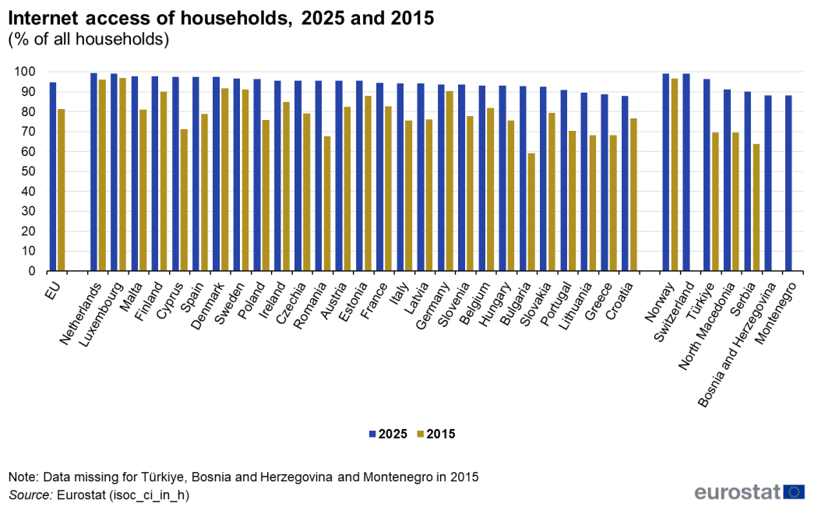
Figure #1. EU Household Internet Access Over Time (2015–2025)
The security environment of the European Union has undergone significant transformation as threats to stability increasingly emerge outside the realm of conventional military conflict. Also, hybrid threats have become a central concern for European institutions due to their ability to undermine democratic governance, economic security, and societal cohesion through coordinated non military means. These threats commonly include disinformation campaigns, cyber attacks, and economic coercion, which are employed in combination to exploit vulnerabilities within these open societies. The European Parliament has taken on an increasingly important role in addressing these challenges, as hybrid threats directly affect democratic processes, the integrity of the single market, and public trust in European institutions.
The European Union is particularly vulnerable to hybrid threats due to its high level of digital integration and economic interdependence. Over 90% of households across Member States have access to the internet, and more than seventy percent of European citizens report using online platforms as their primary source of news. Furthermore, while digital connectivity has strengthened economic growth and cross border cooperation, it has also increased exposure to disinformation and cyber interference. Disinformation campaigns targeting European audiences have expanded in scale and sophistication. This is backed up by thousands of coordinated cases identified during recent election cycles. These campaigns often exploit political polarization and social divisions, and they amplify false narratives that weaken trust in democratic institutions.
Cyber attacks represent another major component of hybrid threats facing the European Union. Public institutions, healthcare systems, financial services, and energy infrastructure have increasingly become targets of malicious cyber activity. Reports from European institutions indicate that the number of significant cyber incidents affecting Member States has increased steadily over the past decade, with year on year growth exceeding 40% in some reporting periods. This is especially problematic due to the interconnected nature of digital infrastructure within the Union. Cyber disruptions in one Member State can quickly produce cross border consequences, affecting essential services and economic activity across multiple countries.
Economic coercion further complicates the hybrid threat landscape. The European Union accounts for approximately 15% of global trade, making it one of the most interconnected economic regions in the world. While economic integration has strengthened the Union’s global influence, it has also created strategic dependencies. Several Member States rely heavily on external suppliers for energy, critical raw materials, and advanced technologies, with import dependence exceeding 60% percent in certain sectors.
Hybrid threats present a unique challenge because they often remain below the threshold of armed conflict. Attribution is frequently difficult, responses are constrained by legal and political considerations, and actions taken to counter these threats must balance security objectives with the protection of fundamental rights. Addressing hybrid threats therefore requires coordinated, long term, and preventative approaches that strengthen resilience across political, digital, and economic domains while preserving the values upon which the European Union is founded.

Definition of Key Terms
Hybrid Threats
Hybrid threats refer to coordinated actions that combine political, informational, economic, and digital instruments to influence or destabilize states and institutions without engaging in conventional armed conflict.
Disinformation
Disinformation is the deliberate creation and dissemination of false or misleading information with the intent to deceive audiences, manipulate public opinion, or undermine trust in institutions. In the European Union, disinformation frequently targets electoral processes, public health policy, and debates surrounding European integration.
Cyber Attack
A cyber attack is an intentional attempt to disrupt, damage, or gain unauthorized access to digital systems, networks, or data. Cyber attacks may target government institutions, private enterprises, or critical infrastructure.
Economic Coercion
Economic coercion refers to the use of economic measures such as trade restrictions, investment limitations, or supply chain disruptions to pressure a state into altering political decisions or strategic behavior.
Critical Infrastructure
Critical infrastructure includes physical and digital systems essential to societal and economic functioning, such as energy networks, transportation systems, healthcare services, telecommunications, and financial institutions.

History & Developments
Early emergence of hybrid threats in Europe
Evolution of non military influence
The use of non military instruments to influence political outcomes is not a new phenomenon in Europe. During the Cold War, information manipulation and economic pressure were commonly employed alongside traditional military deterrence. However, the scale and efficiency of such methods increased significantly following the expansion of digital communication technologies in the late twentieth century. By the early two thousands, the rapid growth of internet access across Europe transformed the information environment. Between nineteen ninety eight and two thousand ten, internet usage in the European Union increased from less than 10% of the population to over 65%, fundamentally altering how information was consumed and shared.
Impact of European integration
The deepening of European integration further shaped the hybrid threat landscape. The expansion of the European Union and the creation of the single market increased political and economic interdependence among Member States. While this integration strengthened cooperation and economic growth, it also expanded shared vulnerabilities. A disruption in one Member State could increasingly affect others, particularly in areas such as energy supply, financial services, and digital infrastructure. By 2015, cross border data flows within the European Union had become essential to more than half of all economic activity in the single market.
Early Foundations for Hybrid-Threat attacks
As European states became increasingly reliant on digital networks for governance, finance, and public communication, state and non-state actors began to exploit these systems for political influence and strategic advantage. Russia emerged during this period as a key actor experimenting with hybrid methods. Following the dissolution of the Soviet Union, Russian security doctrine increasingly emphasized information warfare and indirect confrontation as tools to counter Western political influence. This strategic shift laid the foundation for later cyber operations and coordinated disinformation campaigns targeting European institutions and societies.
Growth of disinformation and digital interference
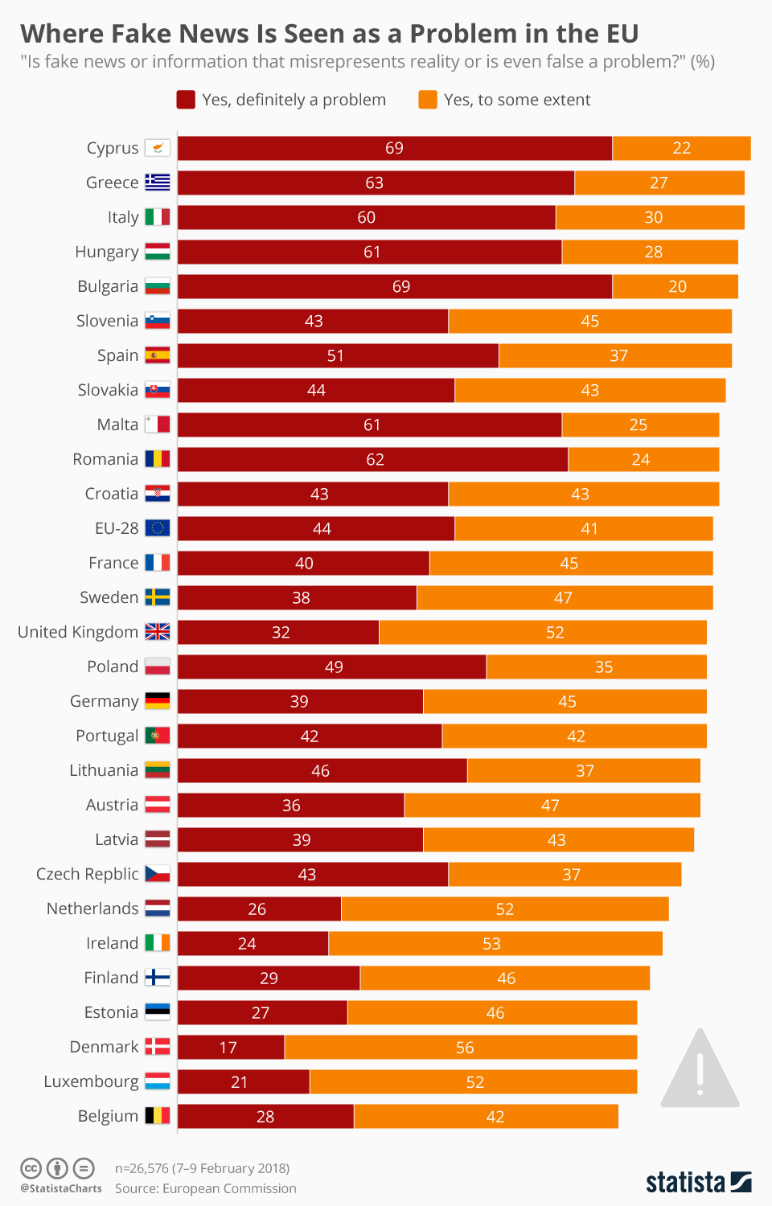
Figure #2: Percentage of Respondents from each EU nation that believe disinformation is a threat to democracy
Expansion of online platforms
The rise of social media platforms in the 2010s marked a turning point in the spread of disinformation. Algorithms designed to maximize engagement often amplified emotionally charged or polarizing content, regardless of accuracy. During major European election cycles, monitoring bodies identified thousands of coordinated disinformation efforts operating across multiple languages and platforms. In the 2019 European Parliament elections, fact checking organizations documented coordinated information campaigns targeting voters in more than twenty Member States.
Targeting democratic processes
Disinformation campaigns increasingly focused on democratic institutions and electoral legitimacy. Studies conducted after recent elections showed that exposure to disinformation correlated with decreased trust in democratic institutions among certain demographic groups. In some Member States, trust in national or European political institutions declined by more than ten points following major disinformation incident.
Russia’s Increasing Disinformation Campaigns
Russian state affiliated media outlets and online networks began disseminating misleading narratives aimed at undermining trus t in European democratic institutions, promoting political polarization, and weakening public confidence in the European Union. These efforts intensified during major political events, including national elections and referendums within Member States. Following the 2014 annexation of Crimea by Russia, European institutions documented a sharp increase in disinformation targeting Eastern and Central European countries. Narratives questioning the legitimacy of European sanctions, promoting distrust toward NATO, and amplifying social divisions were widely circulated across social media platforms such as Instagram and Facebook. By 2018, European monitoring bodies had identified several thousand coordinated disinformation cases linked to Russian sources, prompting the creation of specialized task forces to counter foreign information manipulation. This campaigns only further increased after the beginning of the 2022 Russo-Ukraine war.

Development of cyber threats and digital vulnerability
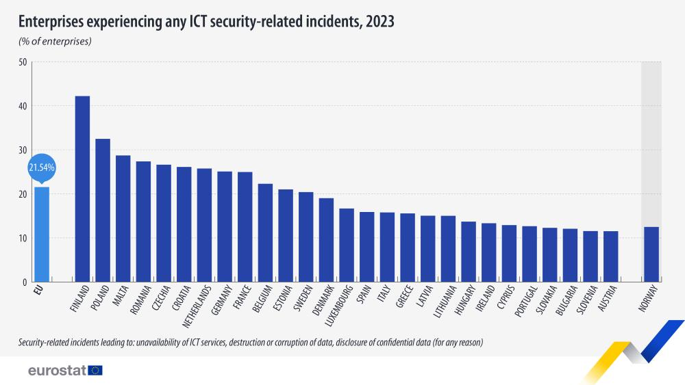
Figure #3: Percent of EU Enterprises experiencing Cyber Incidents in 2023
Increase in cyber incidents
Cyber attacks against European institutions and critical sectors have increased in frequency. Data collected by European cyber security agencies indicates that reported cyber incidents affecting essential services more than doubled between 2016 and 2023. Healthcare systems, energy providers, and public administration services have been among the most frequently targeted sectors. In one reporting year, over one thousand significant cyber incidents were recorded across the Union, with financial losses estimated in the billions of euros. Russian affiliated cyber groups were repeatedly identified by European cyber security agencies as responsible for attacks on government ministries, energy networks, transportation systems, and healthcare institutions. These attacks often coincided with periods of heightened political tension between Russia and European states, such as 2014 onwards and 2022 onwards.
In 2015 and 2016, several European parliaments and ministries reported cyber intrusions aimed at stealing sensitive information and disrupting operations. Germany experienced a major cyber attack on its Bundestag in 2015, later attributed by German authorities to a Russian military intelligence unit. Similar incidents were reported in France, Poland, and the Baltic states. This reinforcing concerns that cyber attacks were being used to exert political pressure rather than achieve purely criminal objectives. Following 2022, the volume and intensity of cyber attacks against European targets increased significantly. European cyber security agencies recorded hundreds of serious incidents affecting critical infrastructure within a single year. Russia was repeatedly identified in public assessments as a primary source of state linked cyber activity, particularly against countries providing political or military support to Ukraine.
Interconnected infrastructure risks
The integration of digital systems across Member States has amplified the potential impact of cyber attacks. Many critical infrastructure systems rely on cross border data exchange and shared digital platforms. As a result, a successful cyber attack on a single system can produce cascading effects across multiple countries. Assessments conducted at the European level have highlighted that disparities in cyber security capacity among Member States increase systemic risk, as weaker defenses in one area may expose the entire network.
Emergence of economic coercion as a strategic tool
Growing economic interdependence
The European Union’s position as one of the world’s largest trading blocs has increased exposure to economic pressure. By 2020, the Union accounted for approximately 15% of global trade in goods and services. While this integration has supported economic growth, it has also created dependencies in critical sectors. In the energy sector alone, several Member States relied on external suppliers for more than 60% of their total energy consumption prior to recent diversification efforts.
Supply chain vulnerabilities
Economic coercion increasingly exploits supply chain concentration and resource dependence. Disruptions in access to raw materials, semiconductors, or medical supplies have demonstrated the vulnerability of highly specialized supply chains. During recent global crises, shortages in essential goods highlighted how economic pressure could be used to influence political decisions or weaken economic stability within the Union. Economic coercion developed as a parallel hybrid tactic as Europe deepened its economic interdependence with external suppliers. Russia played a central role in this development through its position as a major energy exporter to the European Union. Prior to 2022, several Member States relied on Russia for more than forty percent of their natural gas imports, creating significant strategic vulnerability.
Energy supply disruptions and pricing pressures were increasingly used as leverage during political disputes. Following the invasion of Ukraine in 2022, reductions in gas deliveries and price volatility exposed the extent of European dependence on Russian energy resources. These developments accelerated debates within European institutions regarding strategic autonomy, supply diversification, and the risks associated with concentrated economic dependencies.

Major Parties Involved
European Parliament
The European Parliament plays a central role in addressing hybrid threats through its legislative authority, budgetary oversight, and democratic scrutiny of other European Union institutions. As the only directly elected body of the European Union, it represents over four hundred and forty million citizens across twenty seven Member States. The Parliament has been actively involved in shaping legislation related to digital regulation, cyber security, and trade defense mechanisms. Parliamentary committees regularly review threats to democratic processes, particularly during election cycles, and have emphasized the importance of transparency and accountability in countering disinformation. In recent years, the Parliament has increased funding allocations for digital resilience and cyber security initiatives, with budgetary support for related programs exceeding several billion euros across multi year financial frameworks.
European Commission
The European Commission is responsible for proposing legislation and coordinating Union wide strategies to address hybrid threats. It plays a leading role in implementing regulatory frameworks related to digital services, cyber security standards, and economic resilience. The Commission has overseen initiatives aimed at reducing strategic dependencies, particularly in energy and technology sectors. Through policy coordination and funding mechanisms, the Commission supports Member States in strengthening preparedness against cyber attacks and foreign interference. In recent reporting periods, the Commission identified critical dependencies in over one hundred product categories across the European economy, highlighting areas of vulnerability to economic pressure.
European External Action Service
The European External Action Service is responsible for monitoring external threats and coordinating responses to foreign interference targeting the European Union. It plays a key role in identifying disinformation campaigns originating outside the Union and assessing their strategic objectives. Through specialized task forces, the Service has documented thousands of disinformation cases across multiple languages and platforms.
European Union Agency for Cybersecurity
The European Union Agency for Cybersecurity supports Member States by providing technical expertise, training programs, and coordinated risk assessments related to cyber threats. The Agency conducts regular evaluations of cyber preparedness and resilience across the Union. Reports published by the Agency indicate that cyber incidents targeting essential services have increased steadily, with healthcare, energy, and public administration among the most affected sectors. The Agency also coordinates large scale cyber security exercises involving multiple Member States, with participation numbers reaching into the thousands of public and private sector professionals.
Member States of the European Union
Individual Member States remain key actors in addressing hybrid threats, as responsibility for national security and critical infrastructure protection largely rests at the national level. However, disparities in capacity and resources create uneven resilience across the Union. Larger Member States such as Germany, France, or Italy, often allocate significantly higher funding to cyber defense and counter disinformation efforts, while smaller or less resourced states may face shortages of skilled personnel and technical infrastructure.
Private Sector and Digital Platforms
Private companies, particularly digital platforms and infrastructure providers, play a significant role in both the spread and mitigation of hybrid threats. Online platforms serve as primary channels for information dissemination, with a majority of European citizens relying on them for news consumption. At the same time, private sector entities operate much of the critical infrastructure targeted by cyber attacks.
Civil Society and Independent Media
Civil society organizations and independent media outlets contribute to resilience against hybrid threats by promoting transparency, media literacy, and fact based reporting. Research conducted within the European Union indicates that countries with stronger independent media ecosystems experience lower levels of disinformation impact.

Timeline of Events
Note: While the topic doesn’t necessarily hand itself to have a clear timeline of crucial events in which one leads to another, the following is a list of important events regarding the issue, in chronological order. Delegates should still take all of these events into account.
1 November 1993 Entry into force of the Treaty on European Union
The Treaty on European Union, commonly known as the Maastricht Treaty, entered into force and formally established the European Union. This marked a significant expansion of political and economic integration, increasing interdependence among Member States and laying the groundwork for shared vulnerabilities in trade, governance, and infrastructure.
1 May 2004 Largest enlargement of the European Union
Ten new Member States joined the European Union, significantly expanding the single market and increasing cross border economic and political connectivity. This enlargement also highlighted disparities in infrastructure capacity and institutional preparedness across the Union.
6 April 2015 Establishment of the East StratCom Task Force
The European External Action Service established the East StratCom Task Force to identify, analyze, and respond to disinformation campaigns targeting the European Union and its neighboring regions. Within five years, the task force documented several thousand disinformation cases across more than twenty languages.
23 June 2016 Increase in focus on election security and foreign interference
Following heightened concerns about foreign interference in democratic processes across Europe, European institutions began increasing monitoring of election related disinformation and cyber activity. Subsequent assessments recorded year on year increases in election related cyber incidents across multiple Member States.
26 September 2018 Adoption of the Code of Practice on Disinformation
Major online platforms signed the European Union Code of Practice on Disinformation, committing to voluntary measures to reduce the spread of false information, increase transparency in political advertising, and remove coordinated inauthentic behavior. Initial reports indicated the removal of millions of fake or automated accounts.
11 March 2020 Global public health emergency declared
The declaration of a global public health emergency exposed European dependence on external suppliers for medical equipment and pharmaceuticals. In some Member States, import dependence for essential medical supplies exceeded eighty percent, raising concerns about economic coercion and supply chain resilience.
16 December 2020 Adoption of the European Democracy Action Plan
European institutions adopted a comprehensive framework aimed at strengthening democratic resilience, countering disinformation, and protecting electoral integrity. The plan emphasized coordination among Member States and increased oversight of digital platforms.
24 February 2022 Heightened cyber threat environment in Europe
European cyber security agencies reported a sharp increase in cyber attacks targeting public institutions and critical infrastructure. This can largely be attributed to increased hostile relationship with Russia due to the war. In the twelve months following this date, over one thousand significant cyber incidents were recorded across Member States.
23 May 2023 Identification of strategic economic dependencies
The European Commission published an updated assessment identifying over one hundred strategic dependencies across critical sectors, including energy, raw materials, and advanced technologies, prompting further discussion on reducing exposure to economic coercion.

Relevant UN Treaties and Reports
Note: Links to all of the mentioned documents are hyperlinked below
United Nations General Assembly Resolution 68 243, adopted on 27 December 2013
This resolution titled Developments in the field of information and telecommunications in the context of international security affirmed that international law applies to state conduct in cyberspace. It encouraged confidence building measures and international cooperation. European Union cyber security strategies have consistently referenced these principles.
Report of the United Nations Group of Governmental Experts on Developments in the Field of Information and Telecommunications in the Context of International Security, published on 22 July 2015
This report outlined voluntary norms of responsible state behavior in cyberspace, including the protection of critical infrastructure and the avoidance of harmful cyber activity. These norms influenced European approaches to cyber resilience and incident response.
United Nations General Assembly Resolution 73 27, adopted on 5 December 2018
This resolution reaffirmed earlier commitments to responsible state behavior in cyberspace and emphasized the importance of capacity building for developing states. European Union institutions have supported these objectives through international cooperation and assistance programs.
United Nations General Assembly Resolution 75 240, adopted on 31 December 2020
This resolution encouraged further dialogue on reducing risks of conflict stemming from cyber activities and emphasized the importance of protecting critical infrastructure. European Union policy frameworks have aligned with these objectives in addressing hybrid threats.

Possible Solutions
Strengthening media literacy and public awareness across Member States can reduce the societal impact of disinformation campaigns. Research conducted within the European Union indicates that individuals with formal media literacy training are significantly less likely to share false or misleading information online. Surveys across multiple Member States show that up to 60% of citizens encounter disinformation weekly, yet fewer than half report feeling confident in identifying false content. Delegates need to consider expanding Union supported media literacy programs through national education systems, public broadcasting, and community initiatives.
Enhancing regulatory oversight and transparency requirements for digital platforms can limit the spread of coordinated disinformation. Online platforms remain primary channels through which false narratives spread, with over seventy percent of European citizens relying on digital sources for news. Requiring standardized transparency reporting on content moderation practices and political advertising would allow for consistent evaluation across platforms and Member States.
Increasing investment in cyber security infrastructure and workforce development can improve protection of critical systems. European institutions estimate that the Union faces a shortage of several hundred thousand cyber security professionals, creating persistent vulnerabilities in both public and private sectors. Possible solution for delegates is expanding Union funded training programs, scholarships, and cross border professional exchanges.
Harmonizing cyber incident reporting and response mechanisms across Member States can reduce systemic risk. While most Member States have adopted cyber security reporting requirements, differences in standards and response procedures remain significant. Delegates should establish clearer Union wide protocols for incident classification, reporting timelines, and information sharing.
Reducing strategic economic dependencies through diversification and internal investment can limit exposure to economic coercion. Assessments by European institutions have identified over one hundred critical dependencies in sectors such as energy, raw materials, and advanced technologies. In some areas, import reliance exceeds seventy percent, creating opportunities for external pressure. Investing in domestic production capacity, alternative supply routes, and diversified trade partnerships could strengthen economic resilience while preserving the benefits of open markets.
Strengthening coordination between trade policy and security considerations can improve responses to economic pressure. Economic coercion often operates through legal trade mechanisms, making it difficult to address using existing frameworks. Improving coordination between economic and security institutions could allow for earlier identification of coercive practices and more timely responses.
Enhancing institutional coordination and oversight can improve the overall effectiveness of Union responses to hybrid threats. Hybrid threats frequently target multiple sectors simultaneously, requiring cooperation across European institutions and national authorities. Establishing regular review mechanisms within the European Parliament to assess the effectiveness of Union strategies could strengthen accountability and adaptability.

Bibliography
BEAULIEU, BRITTANY, and STEVEN KEIL. Projecting Division in Transatlantic Societies. German Marshall Fund of the United States, 2018, https://doi.org/10.2307/resrep18872
JSTOR
Bertolini, Mattia, et al. Ten Guidelines for Dealing with Hybrid Threats a Policy Response Framework. 2023, hcss.nl/wp-content/uploads/2023/04/Guidelines-for-the-Deterrence-of-Hybrid-Threats-HCSS-2023.pdf
Bryant, Miranda. “Denmark Says Russia Was behind Two ‘Destructive and Disruptive’ Cyber-Attacks.” The Guardian, The Guardian, 18 Dec. 2025, www.theguardian.com/world/2025/dec/18/denmark-says-russia-was-behind-two-destructive-and-disruptive-cyber-attacks Accessed 20 Dec. 2025.
“CCDCOE.” Ccdcoe.org, ccdcoe.org/incyder-articles/eu-policy-on-fighting-hybrid-threats/
Comms Editor. “The EU’s Approach towards Countering Hybrid Threats: Conceptualization and Capacity Building - Finabel.” Finabel - Finabel Promotes the Interoperability of European Land Forces, Whilst Complementing EU and NATO Structures, through Research and Decision-Making Recommendations., 18 Oct. 2024, finabel.org/the-eus-approach-towards-countering-hybrid-threats-conceptualization-and-capacity-building Accessed 20 Dec. 2025.
“Countering Hybrid Threats.” Site Name Seo, 2025, www.nato.int/en/what-we-do/deterrence-and-defence/countering-hybrid-threats
Dengg, Anton, and Michael Schurian. Schriftenreihe Der Landesverteidigungsakademie Networked Insecurity - Hybrid Threats in the 21 St Century. 2016, www.bmlv.gv.at/pdf_pool/publikationen/2016_17_sr__networked_security_dengg_schurian.pdf Accessed 20 Dec. 2025.
“EU-HYBNET – Empowering a Pan-European Network to Counter Hybrid Threats.” Euhybnet.eu, 16 Dec. 2021, euhybnet.eu/ Accessed 20 Dec. 2025.
Eurostat. “21.5% of EU Enterprises Had ICT Security Incidents in 2023.” @EU_Eurostat, Eurostat, 8 Oct. 2025, ec.europa.eu/eurostat/web/products-eurostat-news/w/ddn-20251008-1
---. “Digital Economy and Society Statistics - Households and Individuals - Statistics Explained.” Ec.europa.eu, Dec. 2024, ec.europa.eu/eurostat/statistics-explained/index.php?title=Digital_economy_and_society_statistics_-_households_and_individuals
Gressel, Gustav. PROTECTING EUROPE against HYBRID THREATS. European Council on Foreign Relations, 2019, https://doi.org/10.2307/resrep21494 JSTOR.
Hanlon, Bradley. “It’s Not Just Facebook: Countering Russia’s Social Media Offensive.” JSTOR, 2018, www.jstor.org/stable/resrep18880
Hybrid CoE. “Hybrid Threats as a Concept.” Hybrid CoE - the European Centre of Excellence for Countering Hybrid Threats, www.hybridcoe.fi/hybrid-threats-as-a-phenomenon/.
“Hybrid Threats.” Defence-Industry-Space.ec.europa.eu, defence-industry-space.ec.europa.eu/eu-defence-industry/hybrid-threats_en
“Hybrid Warfare and the Changing Character of Conflict on JSTOR.” Jstor.org, 2016, https://doi.org/10.2307/26326440 Accessed 22 Oct. 2024.
Jazeera, Al. “Cyberattack on European Airports Caused by Ransomware, EU Finds.” Al Jazeera, 22 Sept. 2025, www.aljazeera.com/news/2025/9/22/cyberattack-on-european-airports-caused-by-ransomware-eu-finds
Marcuzzi, Stefano. Presentation from the Max Weber International Workshop “Fears of Trolls and Little Green Men. Does Hybrid Warfare Work, for Whom, and When?” Hybrid Warfare in Historical Perspectives. www.natofoundation.org/wp-content/uploads/2018/06/NDCF_StefanoMarcuzzi_Paper.pdf
Monaghan, Sean, and Tim McDonald. “Conclusion: Towards a Systems Approach to Countering Hybrid Threats.” Campaigning in the Grey Zone, Hague Centre for Strategic Studies, 2023, pp. 19–19, https://doi.org/10.2307/resrep53858.8 JSTOR.
Raugh, David L. “Is the Hybrid Threat a True Threat?” Journal of Strategic Security, vol. 9, no. 2, University of South Florida Board of Trustees, 2016, pp. 1–13, https://doi.org/10.2307/26466774 JSTOR.
ROBBINS, JOSEPH W., et al. “Countering Russian Disinformation.” The Diversity of Russia’s Military Power, Center for Strategic and International Studies (CSIS), 2020, pp. 32–39, https://doi.org/10.2307/resrep26533.8 JSTOR.
Russell, Alison Lawlor. Cyber Blockades. Georgetown University Press, 2014, https://doi.org/10.2307/j.ctt9qdsfj JSTOR.
“Russia Import Dependency Problem |.” Ecipe.org, ecipe.org/blog/russia-import-dependency-problem/
Sarwar, Dilshad, and Sara Rye. “The Impact of the Russia-Ukraine War on Global Supply Chains: A Systematic Literature Review.” Frontiers in Sustainable Food Systems, vol. 9, Frontiers Media, Sept. 2025, https://doi.org/10.3389/fsufs.2025.1648918

