Forum: Human Rights Council
Issue: Combating child marriage in rural regions
Student Officer: Chandana Jelli
Position: Deputy President

Introduction
Child marriage remains a consistent human rights violation especially in rural regions, in which education is limited and social norms are strongly enforced. A report by United Nations Population Fund (UNFPA) shows that an estimated 640 million of girls and women today were married in childhood and every year 12 million adolescent girls are married before they reach the age of 18. Child marriage is usually backed by reasons such as cultural expectations and social hierarchy. According to the UNFPA – UNICEL Global Program, there has been progress, but many rural communities face barriers like poverty, little to no legal enforcement and archaic traditions. Economic status and education strongly influence the risk of child marriage, girls from the poorest households are far more likely to marry earlier compared to the girls from wealthier families, and girls with little to no formal educational opportunities are significantly more vulnerable and at risk. Overall child marriage in rural areas highlights the limited opportunities, and gender inequality.
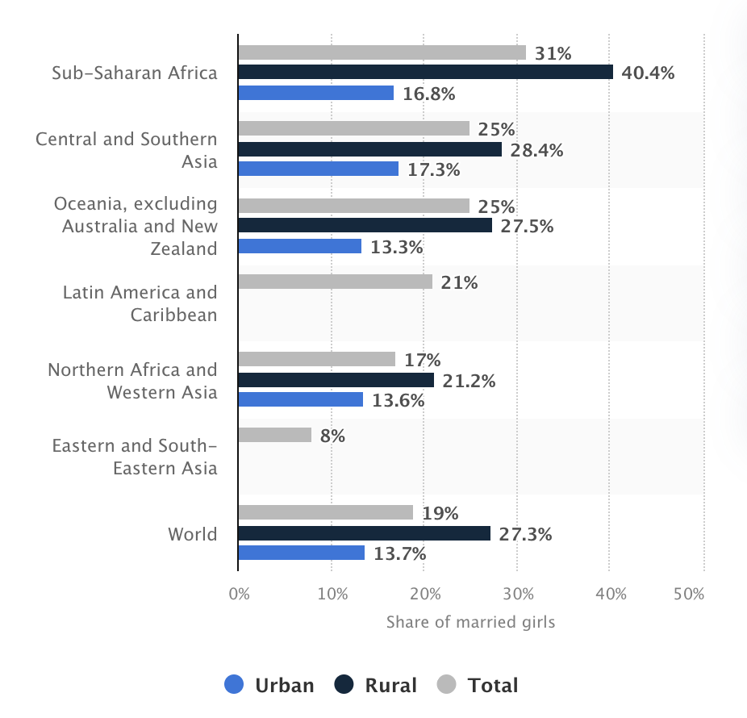
Figure 1: Prevalence of child marriage worldwide in 2024 by region and place of residence
While child marriage happens to both boys and girls, the frequency of it is about 5 times higher among girls, which shows and reflects the societal values that hold girls in low esteem and depriving them of the freedom to live their own life.
Child marriage carries serious long-term consequences on a girl’s health, such as childbirth complications, increasing the likelihood of death in girl aged 15 to 19, and infants born to teenage mothers are more likely to have low birth weight, and are likely to be malnourished. Studies also show that education has a protective effect on women, especially those who have been married against their will or at a young age, literate women are more likely to know basic facts about HIV and their children are more likely to survive past the age of five.

Definition of Key Terms

Child Marriage
Child marriage is a human rights violation which refers to any formal or informal marriage or union of a child with an adult or another child. Child marriage is deeply linked to gender inequality, poverty and harmful social norms limiting the life opportunities and health of young kids. Globally about 1 out of 5 girls marry before they turn 18, which forces them to leave school and exposes them to an early pregnancy and increases their risk of violence.
Forced Marriage
Forced marriage means a marriage with one or more elements of force, fraud or coercion where either party can’t or doesn’t consent to the marriage. It may occur when family members use physical or emotional abuse, threats, or deception to force them to marry without consent. It can happen to people of any ethnicity religion, sex, gender or age.
Gender Inequality
Gender inequality is a condition that access to rights, opportunities, and resources are unequally distributed between genders including but not limited to women, men, girls, boys and people of other gender identities.
Harmful Practices
Harmful practices are cultural practices in the form of gender-based violence and a violation of human rights. that can negatively affect the health, wellbeing and dignity of women and children. A variety of these practices exist, such as female genital mutilation (FGM), child and forced marriage, virginity testing and witchcraft accusations, and body modifications.
Dowry
Dowry is a cultural practice where the bride’s family makes payment of money or assets to the groom at the time of marriage. Originally meant to ensure financial security for women, is now a cause of violence against women including killings and abuse over disputes regarding the dowry. Dowry is more prevalent in certain south Asian countries, where it’s a part of wedding customs and has been observed in certain middle east, eastern Europe and Mediterranean cultures.

History & Developments

Early origins of child marriage practices
Child marriage has existed for centuries across regions in Africa, South Asia and the middle east. Historically, the practice began as a way to strengthen family alliances, preserve property and assets, or ‘protect girls' honors. In rural societies where children were often considered economic resources, child marriage was seen as a practical decision. Social norms meant that girls were valued for their domestic and reproductive roles, which further reinforced the idea of them marrying at a young age. In many cultures and communities, children were considered adults when they reached puberty, creating a cultural acceptability for marriages at young ages.

Traditional systems and customary laws
In many rural areas, religious and customary laws have historically overseen marriage over legal systems. These local laws often legalize and legitimize early marriage and prioritize family welfare and stand over the consent of individuals. Customary law is more often unwritten and enforced by ‘elders’ or religious readers; it’s not an easy tradition to reform. Even if places have national laws that prohibit underage marriage or forced marriages, a lack of local enforcement ensures the continuation of these traditional systems to continue operating.

Dowry, bride price, and economic motivations

Child marriage is mainly sustained and practiced because of the economic benefits of either party. In communities which practice bride price, marrying a daughter early can provide immediate financial benefit, and in dowry-based systems, younger brides typically mean lower demands for dowry. Poverty, lack of food, and lack of employment opportunities, specially make child marriage a survival strategy for households.

Global recognition of child marriage as a human rights violation

Rise of internation human rights frameworks

Child marriage wasn’t widely recognized as a human rights violation until the last 20th century. The adoption of internation treaties such as Convention on the Rights of Child and the Convention on the Elimination of All Forms of Discrimination Against Woman established that children can’t provide consent to marriage. The Programme of Action of the International Conference on Population and Development in 1994 also called on countries to eliminate child marriage. These frameworks highlighted child marriage as a violation of children’s rights, women’s rights and gender equality rather than an issue about culture and tradition

Shift towards global data collection

From the 1990s onward, UN organizations and agencies began collecting systemic data on child marriage through surveys. These data revealed that child marriage affects girls in rural and low-income communities more than children in urban and city backgrounds. This evidence helped governments and international organizations organize targeted measures and interventions to help measure progress over time.

Child marriage among girls

Around the world, child marriage is highest in central and west Africa where over 30% of young women were married as a child. However, these numbers aren’t as high in countries in southern Africa, south Asia, and Latin America. The prevalence of child marriage is decreasing year by year, with the most progress in south Asia, where numbers have dropped by a third in the past decade. However, these numbers are still 13 million per year.

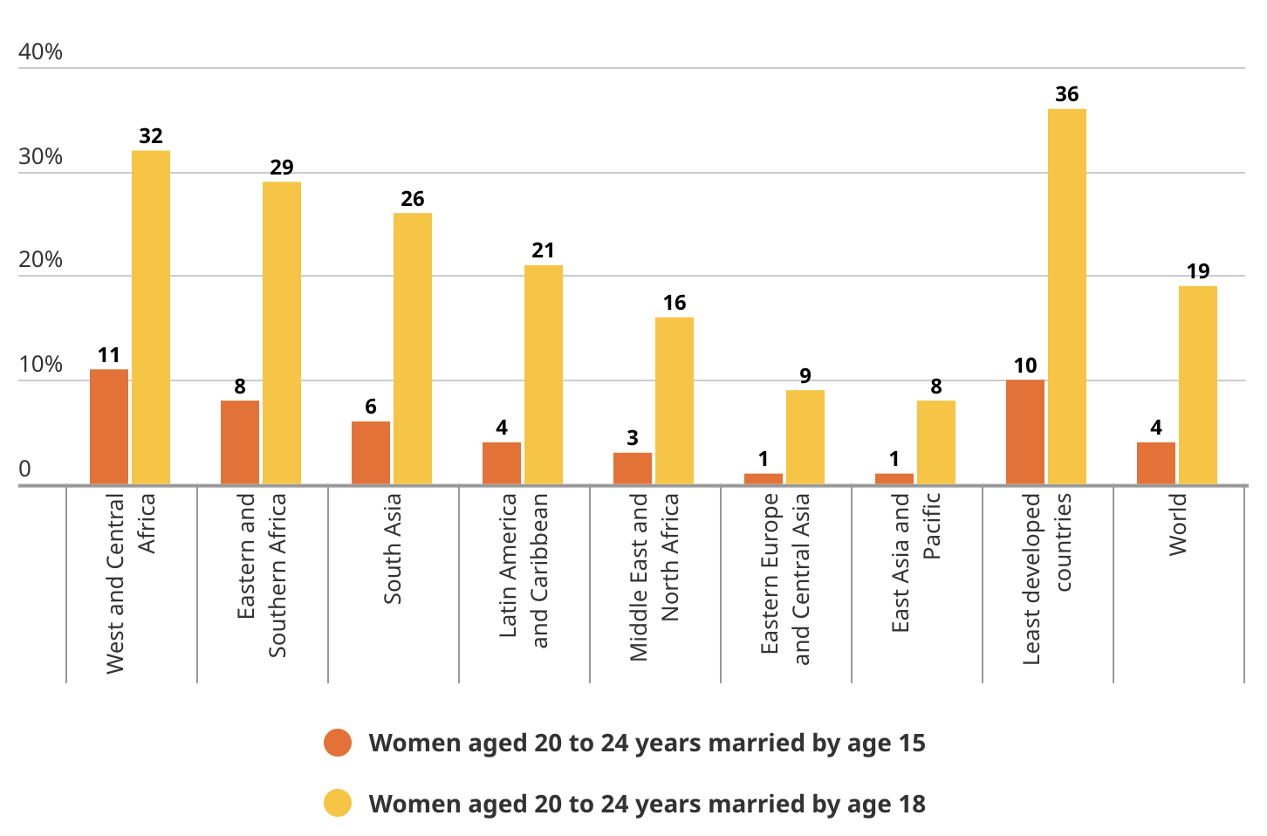

Figure 2: Young women aged 20-24 married under the age of 18

Child marriage among boys

While boys and girls who marry as a child don’t face the same consequences due to biological and social differences, it is still a human rights violation for both genders. Child grooms are forced to take on responsibilities for which they are not prepared for and to lose their childhoods. Early marriage can potentially lead to early fatherhood, increasing the probability of extra stress and economic pressure to provide for their household. Globally 115 million boys and men were married underage. While child grooms aren’t as common as child rights, they similarly experience a human rights violation that cuts their childhood short.

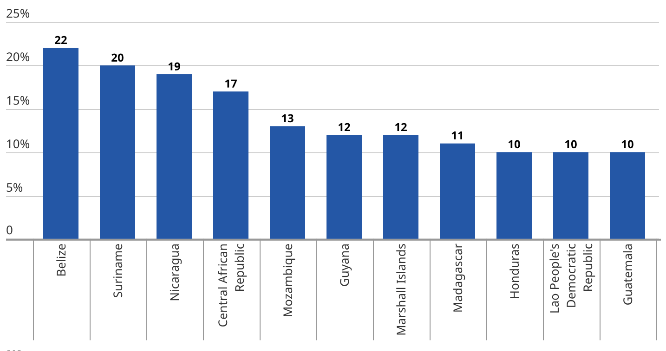

Figure 3: Young men aged 20-24 married before the age of 18

Major Parties Involved

United Nations Children’s Fund (UNICEF)
The United Nations Children’s Fund is a united nations organization who’s core interests are to protect children’s rights and welfare, the prevent child marriage by keeping girls in school and reduce gender inequality and harmful social norms in rural communities. UNICEF co-leads the UNFPA-UNICEF Global Programme to End Child Marriage and works with governments, NGO’s and local partners in countries with a high prevalence of child marriage.

United Nations Population Fund (UNFPA)
The UNFPA is an organization that seeks to empower adolescent girls, improve sexual and reproductive health, and reduce early marriage and early childbirth. UNFPA is another co-leader of the UNFPA-UNICEF Global Programme to End Child Marriage and works across education, health and gender equality sectors. The UNFPA also advises and funds governments to reform laws and policies, Partners with UNICEF, NGO’s and local activist groups. UNFPA is supported by donor governments and international institutions.

Girls Not Brides
Girls not Brides is a global NGO organization which aims to end child marriage through advocacy, community actions and policy changes, and aims to empower the voices of girls and community led organizations. Girls Not Brides has a global partnership over 1,400 NGO’s and supports national partnerships such as Girls Not Brides India. This organization works with governments to try to help influence national laws and policies in order to reduce and eradicate the prevalence of child marriage. Girls Not Brides collaborates with UNICEF, UNFPA and other international NGOs and tries to help NGOs in rural areas enforce global policy.

Government of India
The government of India governs over a nation with an extremely high prevalence of child marriage, especially in its rural regions. The aim of the Indian Government includes enforcing laws against child marriage, improving education for girls, and general welfare. The Government has national laws such as the Prohibition of Child Marriage Act (2006) and implements national and state level campaigns that involve health, education and child protection organizations. The Government of India is also a partner country in the UNFPA-UNICEF Global Programme. And works with UNFPA and UNICEF for funding and technical support, collaborated with NGOs like Girls Not Brides India, and coordinates with local governments and community leaders in rural areas.

Plan International
Plan International is an international NGO that seeks to end child marriage by promoting girls’ education and gender equality. It addresses poverty and societal traditions that sustain and encourage child marriage in rural areas. Plan International is an active member of Girls Not brides and partners in national child protection and educational programs. Plan international works with national governments to implement community led programmed and collaborated with UNICEF, UNFPA, Save the Children and local NGOs and is funded by donor governments and international institutions. Plan International operates all around the world in locations such as Middle East, Eastern and Southern Africa, West and central Africa, Asia and pacific, and the Americas and the Caribbean.

Government of Malawi
The government of Malawi is a country with a strong traditional leader involvement in combating and aiding the efforts against child marriage. The country aims to reduce the high national rates of child marriage through education and awareness. In order to effectively regulate and combat, they have made a constitutional amendment that raises the legal marriage age to 18 and have implement national strategies that align with UN child protection frameworks and cooperates closely with NGOs and tradition leaders at community levels.

Timeline of Events
Date | Event Name | Description
December 10, 1948 | The Universal Declaration of Human Rights | Adopted by the United Nations General Assembly, establishing fundamental human rights standards including limitations on non-consensual marriage
December 9, 1964 | The Convention on Consent to Marriage, Minimum Age for Marriage and Registration of Marriages | Treaty signed upon in the United Nations on the standards of marriage, drafted by the commission on the status of women and opened for signature and ratification by the General Assembly
September 27, 2013 | Human Rights Council resolution on child, early and forced marriage | Adopted in the human rights council calling got the elimination of child, early and forced marriage, unanimously adopted and first to be passed on the issue at the human rights council
November 21, 2014 | Adoption of major resolution on child, early and forced marriage in UN General Assembly | Resolution calls on states including religious and community leaders to develop and implement comprehensive and coordinated responses and strategies to eliminate child early and forced marriage and to support already married girls and adolescents

Previous Attempts to Solve the Issue
One of the earliest international attempts to address child marriage was the Convention on Consent to Marriage, Minimum Age for Marriage and Registration of Marriage was adopted by the United Nations General Assembly in 1962. This convention requires states and member nations to ensure free and full consent to marriage, establish a minimum legal age, and make the registration of marriages mandatory. It did end up laying out important legal groundwork; however, limited ratification and little to no enforcement in rural regions reduced the overall impact of the convention.
Another major attempt was the adoption of the Convention on the Elimination of All Forms of Discrimination Against Women (CEDAW) in 1979. This treaty defined child marriage as a form of discrimination against women and made member states to ensure equality in marriage. CEDAW encouraged governments to reform domestic laws accordingly; however, upholding traditions and legal loopholes allowed child marriage to continue operating in rural areas.
In 2013, the United Nations Human Rights Council adopted its first resolution specifically addressing child, early and forced marriages, formally recognizing the practice as a human rights violation. The resolution called on states to strengthen legislation, address child marriage’s root causes such as poverty and gender inequality and improve access to education. However, since the resolution was non-binding, the effectiveness of it depended on the implementation of the countries.
Another well-known effort was the 2030 Agenda for sustainable development in 2015 introduces sustainable development goal target 5.3, which aimed to eliminate all harmful practices including child early and forced marriage by 2030. This target integrated child marriage prevention into global development strategies. In spite of that, current progress shows that many rural regions are not on track to meet the goal due to a multitude of reasons such as lack of enforcement, tradition and so on.

Relevant UN Treaties and Events
- Convention on Consent to Marriage, Minimum Age for Marriage and Registration of Marriages, November 11th, 1962, A/RES/1763 (XVII) [A] – Established the requirement for free and full consent to marriage and encourages member nations to set a minimum legal age and register marriages.
- Convention on the Elimination of All Forms of Discrimination against Women, December 18th, 1979, A/RES/34/120 – Identifies child marriage as a form of discrimination against women and obligates states to ensure equality in marriages
- Convention on the Rights of the Child, November 20th, 1989, A/RES/44/25 – defines anyone under 18 as a child and requires states to protect children from harmful practices including child marriages.
- UNHRC on Child, Early and Forced marriage, October 9th, 2013, A/HRC/RES/24/23 – First HRC resolution to recognize child, early and forced marriage as a human rights violation.
- UNICEF-UNFPA Global Programme to End Child Marriage, March 2016 – Joint UN programme that supports governments through legal reforms and education initiatives in countries with high prevalence of child marriage.

Possible Solutions
Strengthening and enforcing national legal frameworks is a crucial stem in combating child marriage in rural regions. Governments should establish a minimum legal age of marriage at 18 without exceptions and ensure regulation through monitoring mechanisms. Improving birth and marriage registration systems could potentially help underage marriages from going unreported, especially in rural communities where enforcement is often weak.
Another potential solution can be expanding access to quality education for girls, as it is one of the most effective long-term solutions to child marriage. Nations like Malawi that are already implementing this are beginning to see results. Girls who remain in school are significantly less likely to be married early, since education increases awareness and keeps them open to future opportunities.
Addressing poverty through economic support programs can reduce the financial pressures that drive families to marry their daughters. Economic measures and initiatives such as cash transfers, food assistance, job training, and specialization training can help rural households maintain economic stability. By reducing reliance on marriage as a coping mechanism, relying on the bride price they might receive, these programs can help directly lower child marriage rates.
Improving access to reproductive health education and services can help reduce early pregnancy, which is often used as a justification for child marriage. Adolescent pregnancy is not only harmful to the mother but the child as well, resulting in a potentially fatal situation, birth complications, or infant mortality. Providing adolescents with accurate information and youth friendly health services can empower girls to make informed decisions about their bodies and their futures and also reduce maternal health risks.
The bottom line is to promote rural development and gender equality initiatives that address the structural and the underlying causes of child marriage. Investing in healthcare, infrastructure, employment opportunities, and basic educational programme to keep girls in school and women empowerment programs can help create environments where early marriage isn’t seen as a necessary financial and social requirement. Strengthening gender equality can help reduce the perception of girls as economic burdens.

Bibliography
Gender Equality: Child Marriage - Unicef Data, data.unicef.org/topic/gender/child-marriage/
Child Marriage | United Nations Population Fund. https://www.unfpa.org/child-marriage.
Forced Marriage | USCIS. 25 Jan. 2025, https://www.uscis.gov/humanitarian/forced-marriage.
‘Global: Child Marriage by Region and Residence 2024’. Statista, https://www.statista.com/statistics/1551436/prevalence-of-child-marriage-worldwide-by-region-and-residence/.
“Child Marriage.” Plan International, plan-international.org/srhr/child-marriage-early-forced/.
“Child Marriage - UNICEF DATA.” UNICEF DATA, 24 Nov. 2025, data.unicef.org/topic/child-protection/child-marriage/#more. Accessed 19 Dec. 2025.
Convention on the Elimination of All Forms of Discrimination against Women. www.un.org/en/development/desa/population/migration/generalassembly/docs/globalcompact/A_RES_34_180.pdf.
“Fact Sheet on Child Marriage.” PRB, www.prb.org/resources/fact-sheet-on-child-marriage/.
“Fighting Early Marriages with Education.” Unicef.org, 2019, www.unicef.org/malawi/stories/fighting-early-marriages-education.
General, UN. “Convention on Consent to Marriage, Minimum Age for Marriage Registration of Marriages.” United Nations Digital Library System, 19 Dec. 2025, digitallibrary.un.org/record/664990?ln=en&v=pdf. Accessed 19 Dec. 2025.
Girls Not Brides. “Girls Not Brides.” Girls Not Brides, 2012, www.girlsnotbrides.org/.
Plan International. “What Is Child Marriage and Why Does It Happen? - Plan International.” Plan International, 2024, plan-international.org/learn/what-child-marriage-why-does-happen/.
September. “States Adopt First-Ever Resolution on Child, Early and Forced Marriage at Human Rights Council - September 2013.” Girls Not Brides, 2015, www.girlsnotbrides.org/articles/states-adopt-first-ever-resolution-on-child-marriage-at-human-rights-council/.
“UN Passes Historic Resolution on Ending Child Marriage.” Who.int, 2025, pmnch.who.int/news-and-events/events/item/2014/11/21/default-calendar/un-passes-historic-resolution-on-ending-child-marriage. Accessed 19 Dec. 2025.
UNFPA. “Child Marriage.” Unfpa.org, 2018, www.unfpa.org/child-marriage.
“UNFPA-UNICEF Global Programme to End Child Marriage.” United Nations Population Fund, www.unfpa.org/unfpa-unicef-global-programme-end-child-marriage.
UNHRC. “Document Viewer.” Un.org, 2025, docs.un.org/en/A/HRC/RES/24/23.
UNICEF. A Desk Review of Evidence from South Asia CHILD MARRIAGE and OTHER HARMFUL PRACTICES. www.unicef.org/rosa/media/9231/file/Child%20Marriage%20and%20Other%20Harmful%20Practices.pdf.
“Child Marriage.” UNICEF DATA, Oct. 2022, data.unicef.org/topic/gender/child-marriage/.
“Child Marriage.” Unicef.org, UNICEF, 2023, www.unicef.org/protection/child-marriage.
“Child Protection.” Www.unicef.org, www.unicef.org/india/what-we-do/child-protection.
“Girls’ Education.” UNICEF, 2023, www.unicef.org/education/girls-education.
United Nations. “Convention on the Elimination of All Forms of Discrimination against Women.” Un.org, 2009, www.un.org/womenwatch/daw/cedaw/.
“Convention on the Rights of the Child.” OHCHR, United Nations, 1989, www.ohchr.org/en/instruments-mechanisms/instruments/convention-rights-child.
“Gender Equality.” United Nations, 2024, www.un.org/en/global-issues/gender-equality.
“Universal Declaration of Human Rights.” United Nations, 10 Dec. 1948, www.un.org/en/about-us/universal-declaration-of-human-rights.
OHCHR. “Harmful Practices.” OHCHR, 2019, www.ohchr.org/en/women/harmful-practices.
“What We Do: Ending Violence against Women.” UN Women, 2019, www.unwomen.org/en/what-we-do/ending-violence-against-women.
Wikipedia Contributors. “Convention on Consent to Marriage, Minimum Age for Marriage and Registration of Marriages.” Wikipedia, Wikimedia Foundation, 2 Feb. 2024, en.wikipedia.org/wiki/Convention_on_Consent_to_Marriage%2C_Minimum_Age_for_Marriage_and_Registration_of_Marriages.

