Forum: United Nations Educational, Scientific, and Cultural Organization (UNESCO)
Issue: Addressing Hate Speech in Southeast Asia
Student Officer: Tony Qiu
Position: President Chair

Introduction
Southeast Asia (SEA) is a broad geographic term, generally referring to the multinational region at the southeast part of Asia, including 11 countries, which are respectively Vietnam, Laos, Cambodia, Thailand, Myanmar, Singapore, Indonesia, Papua New Guinea, the Philippines, Brunei, East Timor, and Malaysia. Despite having a relatively small area, the area has a huge population, making it one of the most population-dense areas in the world.
SEA is geographically separated into two parts: the Indochina Peninsula and the Malay Archipelago, with the former as one of the three major peninsulas of Southern Asia and the latter as the world’s biggest archipelago. SEA is located on the “crossroads” of the continents of Asia and Oceania, and the Pacific and Indian Oceans, acting as a pivotal position in East-West communications.
SEA is an area of immense ethical, cultural, and religious diversity. The entire area is home to people more than 100 ethnic groups. Some of these groups, such as the Kihn people in Vietnam, the Khmer people of Cambodia, the Burmese people of Myanmar, and the Malay people of Malaysia, established their nation states after decolonization in the last century. Meanwhile, other ethnic groups, such as the Miao people, became ethnic minorities in these states. Moreover, the people of SEA believe in a variety of religions, including Roman Catholicism, Theravada Buddhism, Islam and more. Despite having its own culture, Southeast Asia is rather a cultural blend of Chinese, Indian, Islamic, and Western cultural characteristics, with completely different cultural features in different parts, rather than having a unique and united culture. This diversity is mainly caused by its pivotal geographic position, which makes it a hub of cultural exchanges between different major civilizations since thousands of years before. Hence, the people of SEA endured cultural import through a variety of forms including trade, military conquest, and immigration.
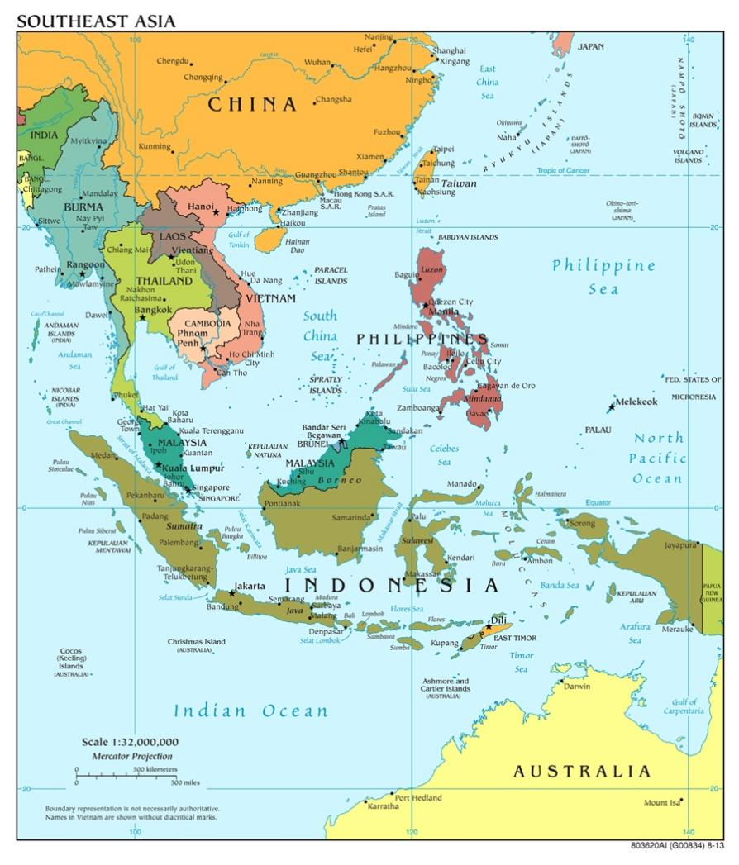
Map of modern Southeast Asia

Hate speech refers to offensive discourse targeting a group or an individual based on their characteristics such as race, religion or gender. Hate speech today is mainly found on internet and social media. The popularization of access to internet enabled hate speech to spread unprecedentedly, making it extremely hard for initiators of hate speech to get punished. However, the root of hate speech is usually found in hatred and conflicts existing between groups in reality. The reason of these hatred could be further traced to political factors keeping those hatred and conflicts from diminishing(explained in “Major Parties Involved” section).
Hatred between groups usually originates from a sense of difference in identity, or the sense of difference between “us” and “them.” Such sense exists between people of all different types of groups, such as ethnic groups, religions, nations, genders, etc. For example, Chinese immigrants are sensed as “them” by Malay indigenous people, or females are sensed as “them” by males. The sense of difference does not necessarily lead to hatred since people can also have a sense of inclusiveness or empathy to people of different identity However, sometimes such sense might be completely outweighed if there is a collective perceptional wave of hatred.
Hate speech in a broader sense could be committed through various forms, such as stigmatization and dehumanization. The former means to regard some group as worthy or deserving of disgrace, disproval, or even mistreatment or bad situations. The latter means to convince others that a groups, as part of humanity, is “less human” than other groups. In addition, scapegoating, the blaming of a group for problems not caused by them, which is usually directed towards minorities, is also a common reason why hate speech and hatred are agitated.
While bringing the area a colorful cultural feature and consequent tourist attraction, the cultural, ethnic, and religious diversity of SEA also enabled hatred to appear between groups to appear. Those hatreds are mostly presented as hate speeches online or offline, but sometimes it goes beyond that and turns into real-world political conflicts or even killings.
The oligarchic sociopolitical structure of countries within that area continuously fertilized those hatred, made it common and widespread, and kept it from deminishing. Oligarchic and dictatorial rulers of these countries keep the society they rule separated into groups that hate each other. They does it in order to prevent the people from getting united and fight for their rights. When their rule fall into crisis, they are especially incentivized to stir up populist hatred more in order to transfer the political conflict and divert the public’s attention. For instance, Haji Soharto, a former dictator of Indonesia, to divert the public’s attention when his holding of power was put in question, once initiated a nationwide brutal massacre targeted toward Chinese immigrants in that country in 1998, causing over 300 thousand innocent civilian deaths and even more harmed or displaced.

Definition of Key Terms

Clan politics
A feudalistic sociopolitical structure dominated by influential families through generations, where descendants of these families usually occupies important positions in the society and government, causing solidification of social classes.
Discrimination
The unjust or prejudicial treatment of different categories of people, especially on the grounds of ethnicity, age, sex, or disability.
Dehumanization
The action of depriving a person or group of positive human qualities in people’s thoughts, a type of hate speech.
Ethinic group
A community or population made up of people who share a common cultural background or descent.
Hate speech
Any kind of communication in speech, writing or behavior, that attacks or uses pejorative or discriminatory language with reference to a person or a group on the basis of who they are, in other words, based on their religion, ethnicity, nationality, race, color, descent, gender or other identity factor. (As defined by the UN Strategy and Plan of Action on Hate Speech)
Genocide
The deliberate killing of a large number of people from a particular nation or ethnic group with the aim of destroying that nation or group.
Ideology
A system of ideas and ideals, especially one which forms the basis of economic or political theory and policy.
Patriarchy
A system of society or government in which men hold the power and women are largely excluded from it.
Religious group
A community or population made up of people who share the belief in and worship of a superhuman controlling power, especially a personal God or gods.
Scapegoating
The action of blaming a person or a group for the wrongdoings, mistakes, or faults of others, especially for reasons of expediency. The scapegoating of a group could be a reason of hate speech against that group.
Social media
Websites and applications that enable users to create and share content or to participate in social networking, currently acting as an effective way of spread of information.
Southeast Asia
The geographic southeastern part of the continent Asia that includes the countries of Cambodia, Indonesia, Laos, Malaysia, Burma (Myanmar), the Philippines, Singapore, Thailand, and Vietnam.
Stigmatization
An action of describing or regarding someone or something as worthy of disgrace or great disapproval, a type of hate speech.

History & Developments
The history of Southeast Asia is a history of incredibly high ethical, cultural, and religious diversity. As the traffic pivot and communication hub between the West Pacific Ocean world and the Indian Ocean world, Southeast Asian societies have been historically reshaped over and over again by foreign powers, ideas, technologies, and religions. The past shaped today’s Southeast Asian people, culture, and society to an extremely large extent.

Pre-modern History of Southeast Asia

Formation of Early States(1st ~10th century AD)
Around the first century of the common era, a dramatic historical shift occurred in the culture and people’s lives of SEA. Due to the occurrence of the Agricultural Revolution, human’s major way of obtaining food shifted from hunting and gathering to agriculture. Migration to places with better agricultural conditions resulted in the shift of population center from mountains to river valleys and coastal areas. The rapid development of productivity and growth of population resulted in the emergence of early states. Social stratification also started to emerge. Meanwhile, minor commercial and cultural exchange occurred between SEA and nearby areas such as China and India. These early states at this point were not politically mature and were mixed with characteristics of primitive societies. The rule of these states were also of relatively small scale and short term, despite political structures at this point have already somewhat developed corresponding to the development of productivity

Pre-Colonial Feudalist Era (11th ~ 17th century)
Another important time period in Southeast Asian history was around 1000s, when feudalist political and economic structures and the cultural features of SEA nation-states took shape.
The history of SEA during this period was characterized by exchangesbetween SEA and the geographically nearby Chinese dynasties, Indian Hindu regimes, and Muslim caliphates, which were all at their historical flourishing period. These exchanges, mainly happening on the then-flourishing Indian Ocean maritime trade networks, blended the early culture, religions, and political ideas of these areas into different parts of SEA. combining with these foreign-imported ideas. During this period, the fragmented political structure, and the cultural pattern highly influenced by multiple surrounding cultures, layed a foundation for SEA’s diversed cultural feature today.
For example, in Vietnam, at the eastern part of the Indochina Peninsula, Wu dynasty was founded in 939, later replaced by other dynasties that replaced each other for multiple times, until Li dynasty took the ruling role in 1009. After Vietnam became an independent state in the 10th century, although Buddhism was taken as state religion and Buddhist monks became part of the ruling class, the entire state was developing toward the shape of Chinese feudalist society. In 1075, Vietnam officially became a Chinese tribute state.
At the western part of the Indochina Peninsula, the Thai and Burmese peoples respectively established Siam (today’s Thailand) and Myanmar as their nation-states, taking Theravada Buddhism as national religions blended with their own cultural characteristics, and developed outstanding civilizations. Warfare between these two ethnic groups with other groups also involved were frequent. The Khmer kingdom (today’s Cambodia) believing in Mahayana Buddhism also once flourished, however declined shortly after the 13th century.
Meanwhile, in the Malay Islands, the influence of Hinduism and Mahayana Buddhism flourished, but later drown out by the influence of Islam after the 14th century. The islands were politically fragmented, with few exceptions when regimes such as the Srivijaya kingdom, shortly ruled vast number of islands.

Modern History of Southeast Asia

Western Colonization (1600s~1950s)

In the three and a half centuries from 1600 to 1950, the entirety of SEA except Thailand, along with vast majority of other lands in the world, were colonized by western imperialist powers.

During the period of colonization, the western world underwent rapid industrial development and economic growth, but at the cost of huge amounts of resources extracted and cheap labortaken from colonies of regions such as SEA. The economic developments and prosperity for the past few centuries was based on this exploitation on colonies like SEA.

Furthermore, although having extremely advanced political systems themselves, the western colonizers did not bring much change to the feudalist oppression the people of SEA were originally undertaking before their arrival. In order to exploit the people and resources in SEA to the most effect and least cost, the colonizers chose to cooperate with instead of replace the local feudalist rulers. The local authorities helped the western colonizers to exploit local peoples and resources, while the latter assisted the former to maintain their rule with their strong military force.

Decolonization (1950s~1980s)

Since the end of the Second World War (1945), colonies around the whole world took advantage of the temporary weakness of their colonizers after the fighting and set off a wave of independence. Although the colonizers attempted to suppress this wave of uprisings, they soon realized their inability to maintain their colonial rule under such intense rebellions. By the 1980s, the colonial rule of all parts of SEA was ended.

When the western colonizers left, they left their parliamentary political system to these former colonial countries that newly gained their independence. However, that did not change the political features of the region. Since western colonizers retained and protected the feudalist ruling families lasted from the pre-colonial times, their descendants continued to comprehensively control the political structure, economy, and society of the SEA nations in the post-colonial times. Most eminent social and political positions were occupied by descendants of these families, and most social resources are also controlled by them. The vast majority of SEA people therefore lives under horrible poverty and heavy oppression.

In 1967, the Association of Southeastern Asian Nations (ASEAN) was founded as a political alliance of six SEA countries at Bangkok, Thailand. At the beginning, the main purpose of the association was to politically confront the socialist camp lead by the Soviet Union, under the background of cold war. Later in 1990, when the Cold War ended, the association expanded its number of member states to ten, and turned its purpose into mutual support and aid in the aspects of economy, society, culture, and technology.

Today’s Southeast Asia

Political Situation

In the status quo, most people of SEA still lives under the heavy political oppression of clan politics, right-wing populism, and corruption. Except for Vietnam and Laos which are governed by communist parties, most SEA nations are currently governed by right-wing populist regimes, with extremely corrupt bureaucracies and parliamentary systems. The peoples struggling at the bottom of societies and some ethnic, religious, or other minority groups are not represented in these countries’ political systems. Hatred and conflicts between ethnic, religious, and other groups are severe, especially toward minorities who are often scapegoated.

Economic Situation

The economic situation of SEA is currently generally pessimistic. 10.5% people of the region lives under the poverty line of spending less than 2.15 dollars a day in September 2023, with more people struggling on the edge of that line, according to the World Bank. This situation is partially caused by the COVID-19 pandemic in the past four years, but mostly caused by the region’s low-end position on the world economy’s supply chain. The poverty in SEA is a major factor leading toward hatred, since public opinions tend to scapegoat certain groups when the entirety of society is in a pessimistic situation.

Cultural Diversity and Discrimination

SEA today still reamains to be one of the world’s most culturally diversed areas. The cultural diversity of SEA caused divisions and even conflicts between groups, which happened during the past few decades. Such divisions and conflicts were especially severe between ethnic groups, such as the conflict in Myanmar between Burmese people and northern ethnic minorities which just broken into war, and the hatred against Chinese immigrants in nearly all SEA nations which has turned violent; and religious groups, such as the conflict between Buddhists and Muslims in Western Indochina Peninsula.

Major Parties Involved

Governments of Southeast Asian Nations
The governments of SEA Nations have been participating in this issue in two aspects.
On one hand, these governments have politically clarified their stance that they actively support the UN’s call on eliminating discrimination. On the legislative level, it is often written in these countries’ laws that hate speech and discrimination are discouraged, disallowed, and should be prosecuted once they appear.
On the other hand, these governments are realistically incentivized to keep the hatred and discrimination from diminishing, due to their nature of being controlled by blocs of influential families. This type of ppressive socio-political structure, known as clan politics, in which descendants of influential families occupied eminent position in the government and society, was formed in SEA nations in pre-colonization times. In order to prevent their oppressed people from uniting and politically struggling against this structure for their rights, these upperclass blocs are incentivized to keep their peoples separated by hatred. Therefore, these governments, based on the structure of clan politics, are also a factor stopping the hatred and separations between groups to diminish.

Governments of Western Nations
The western nations are also closely associated with this issue. They are nowadays active advocators for inclusiveness between groups of different identity, therefore they are a major pushing force toward bringing different groups together. However, they are also currently benefitted from the cheap low-end industrial products produced by labor-intensive industries in less economically developed places such as SEA, and such economic structure is maintained by the current political structure of SEA nations. Therefore, uniting the people of SEA would pose a potential economic threat to western nations.

Association of Southeast Asian Nations (ASEAN)
The ASEAN, founded in 1967 and expanded to the entirety of SEA in 1990, is always a force of adhesion between people of different nations, ethnic groups, and religions. Therefore, the ASEAN would be a great platform if treaties or cooperation are to be made between SEA countries.

UN Bodies Associated with the Addressing of Discrimination
The UN has been always trying to solve or alleviate the problem of hatred and discrimination since its foundation in the 1940s. In its nearly 80 years of history, there are many organizations finding solutions to this problem.
Throughout the 80 years history of the UN, there has been multiple organizations funded by and belonging to the UN being established that focuses on eliminating hatred and discrimination. For example, the Committee on the Elimination of Racial Discrimination (CERD), the International Convention on the Elimination of All Forms of Racial Discrimination (ICERD), the Commission on the Status of Women (CSW), the Office of the United Nations High Commissioner for Human Rights (OHCHR), etc., which are all platforms to have cooperations, negotiations, conferences, and treaties on the addressing of hate speech and hatred.

Previous Attempts to Solve the Issue
In the past decades, governments, organizations, and individuals around the globe have been bravely combating hate speech responding to the call and under the call of the UN. The UN, in its near 80 years of history, has already conducted the establishment of multiple international organizations, the concluding of treaties, the occurrence of events, and the implementation of awareness-raising propaganda aiming toward the elimination of hatred and discrimination.

Relevant UN Treaties and Events
- UN Strategy and Plan of Action on Hate Speech, 2020/9
https://www.un.org/en/genocideprevention/documents/UN%20Strategy%20and%20PoA%20on%20Hate%20Speech_Guidance%20on%20Addressing%20in%20field.pdf
- International Convention on the Elimination of All Forms of Racial Discrimination, 1965 (entered into force in 1969)
https://www.ohchr.org/en/instruments-mechanisms/instruments/international-convention-elimination-all-forms-racial
- The UN Committee on the Elimination of Racial Discrimination founded, 1969
- The Universal Declaration of Human Rights, 1945
https://www.un.org/en/about-us/universal-declaration-of-human-rights

Possible Solutions
Currently, the most urgent action to take to address hate speech is to clarify the border between free speech and hate speech. As the United Nations Secretary-General António Guterres once said in May, 2019, “Addressing hate speech does not mean limiting or prohibiting freedom of speech. It means keeping hate speech from escalating into something more dangerous, particularly incitement to discrimination, hostility and violence, which is prohibited under international law.” In the status quo, the legislative system of most countries adhere to the principle of free speech, and there is often no clear bright line drawn between “free speech” and “hate speech.” Therefore, in practical cases, people who are accused of conducting hate speech would often argue that their actions are within the range of free speech, enabling them to escape from legal punishments even if harsh legal punishments to hate speech theoretically exists. With that being the case, if delegates want to impose legal punishments or prosecutions to hate speech in resolutions, it is crucial to first draw a clear line between “hate speech” and “free speech,” or else the prosecutions or punishments might be not effective or not implemented.
Another possible solution is to directly prosecute hate speech. This could be done in various ways, such as tracing down initiaters of hate speech, strengthen legal punishments, and reduce the effect of hate speech using technological measures. Please note that it is hard for UN bodies or governments of nations to do this on their own without collaborating with other relative stakeholders such as civil society organizations, media outlets, social media platforms, and more.
Finally, a way of solving the problem from its root is to make systematic and structural reforms in Southeast Asian countries in their governments, economy, and society. This could be done through the improvement of government transpearency, the decrease of clan politics’ effects, the supervision of governmental operation by anti-corruption organizations operating beyond governmental systems, the prosecution of corrupt officials, etc. However, delegates of SEA countries should be careful about supporting structural reforms in their own countries, since too much reform could potentially cause socio-political instability and chaos, and you are representatives of governments under the current system afterall. Delegates of western MEDCs should also be careful about advocating for these reforms, since your countries are currently economically benefitted by the structure in the status quo.

Bibliography

"Association of Southeastern Asian Nations." Baidu Baike, baike.baidu.com/item/东南亚国家联盟/1059562?fr=ge_ala#5. Accessed 8 Nov. 2023.
Baah, Samuel K., et al. "September 2023 global poverty update from the World Bank: new data on poverty during the pandemic in Asia." World Band Blogs, 20 Sept. 2023, blogs.worldbank.org/opendata/september-2023-global-poverty-update-world-bank-new-data-poverty-during-pandemic-asia. Accessed 8 Nov. 2023.
‌ “Diversity & Inclusion in Asia: Let’s Talk about Ethnicity and Race.” The Conference Board, 22 Feb. 2021, www.conference-board.org/publications/diversity-inclusion-in-asia. Accessed 6 Nov. 2023.
Gutteres, António. "United Nations Strategy and Plan of Action on Hate Speech: Detailed Guidance on Implementation for United Nations Field Presences." un.org, Sept. 2020, www.un.org/en/genocideprevention/documents/UN%20Strategy%20and%20PoA%20on%20Hate%20Speech_Guidance%20on%20Addressing%20in%20field.pdf. Accessed 8 Nov. 2023.
Guterres, António. “UN Strategy and Plan of Action on Hate Speech.” un.org, United Nations, 18 June 2019, www.un.org/en/hate-speech/understanding-hate-speech/hate-speech-versus-freedom-of-speech. Accessed 6 Nov. 2023.
河畔的伯爵. "Why did ancient Southeast Asia move towards Indianization despite its proximity to China." Bilibili, 30 June 2023, www.bilibili.com/video/BV1G14y1m7Y7/?spm_id_from=333.1007.top_right_bar_window_history.content.click&vd_source=694b7e2e303b6375dc5093f78f5734df. Accessed 8 Nov. 2023.
"History of Southeast Asia." Baidu Baike, baike.baidu.com/item/东南亚历史/23251019. Accessed 8 Nov. 2023.
江湖弃子. "Motorcycle army, clan politics, tribal conflicts, a video to understand modern Southeast Asia." Bilibili, 20 July 2022, www.bilibili.com/video/BV1s3411F71J/?spm_id_from=333.1007.top_right_bar_window_history.content.click&vd_source=694b7e2e303b6375dc5093f78f5734df.
JW531. "Chinese among Others: Southeast Asian Chinese Society during the Postcolonial Period." Bilibili, 2 June 2023,
Severino, Rodolfo. “Managing Southeast Asia’s Fractured Societies - ViewsWeek.” ViewsWeek, 13 Jan. 2014, viewsweek.com/managing-southeast-asias-fractured-societies/. Accessed 6 Nov. 2023.
“Southeast Asia - Ethnic Groups, Religions, Languages | Britannica.” Encyclopædia Britannica, 2023, www.britannica.com/place/Southeast-Asia/People. Accessed 6 Nov. 2023.
"Southeast Asia (Southeastern Part of Asia)." Baidu Baike, baike.baidu.com/item/东南亚/390261?fr=ge_ala. Accessed 6 Nov. 2023.
‌ United Nations. “Hate Speech versus Freedom of Speech | United Nations.” United Nations, un.org, 14 Jan. 2022, www.un.org/en/hate-speech/understanding-hate-speech/hate-speech-versus-freedom-of-speech. Accessed 6 Nov. 2023. www.bilibili.com/video/BV1CN41117Rb/?spm_id_from=333.1007.top_right_bar_window_history.content.click&vd_source=694b7e2e303b6375dc5093f78f5734df. Accessed 8 Nov. 2023.
United Nations High Commition of Human Rights. "International Convention on the Elimination of All Forms of Racial Discrimination." un.org, United Nations General Assembly resolution 2106 (XX), 21 Dec. 1965, www.ohchr.org/en/instruments-mechanisms/instruments/international-convention-elimination-all-forms-racial. Accessed 8 Nov. 2023.
United Nations General Assembly. "Universal Declaration of Human Rights." un.org, UN General Assembly resolution 217 A, 10 Dec. 1948, www.un.org/en/about-us/universal-declaration-of-human-rights. Accessed 8 Nov. 2023.
United Nations. “What Is Hate Speech? | United Nations.” un.org, United Nations, 14 Jan. 2022, www.un.org/en/hate-speech/understanding-hate-speech/what-is-hate-speech. Accessed 6 Nov. 2023.

