Forum: United Nations International Children's Fund
Issue: Ensuring the safety, wellbeing and quality of life of children within active warzones
Student Officer: Derek Ding
Position: President

Introduction
According to the Global Peace Index of 2025, 59 active state-based conflicts are currently occurring across the world. That amount is the most since the end of the Second World War. In the past year, 3 new conflicts have risen. The ending of conflicts through peace agreements fell by 19% from 23% in the 1970s to 4% in the 2010s. There has also been a rise in conflict between nations rather than within the nation itself with 78 countries engaging in cross-border conflicts. This hinders and complicates the solution-making process for conflicts as it may be influenced by a plethora of international factors. For example, on October 10th, 2025, a ceasefire was declared on Gaza where Hamas has to release all hostages in return for 2,000 Palestinian prisoners of war held in Israel to be released within 72 hours. Because of the ceasefire, Hamas released 47 hostages, 20 alive and 27 dead, back to Israel. However, it is claimed by Israel that 48 individuals were still kept hostage in Gaza when the hostages were released. As a result, Israel continues to launch attacks on Palestine despite the ceasefire, violating the ceasefire 875 times and killing 406 people as of December 22.
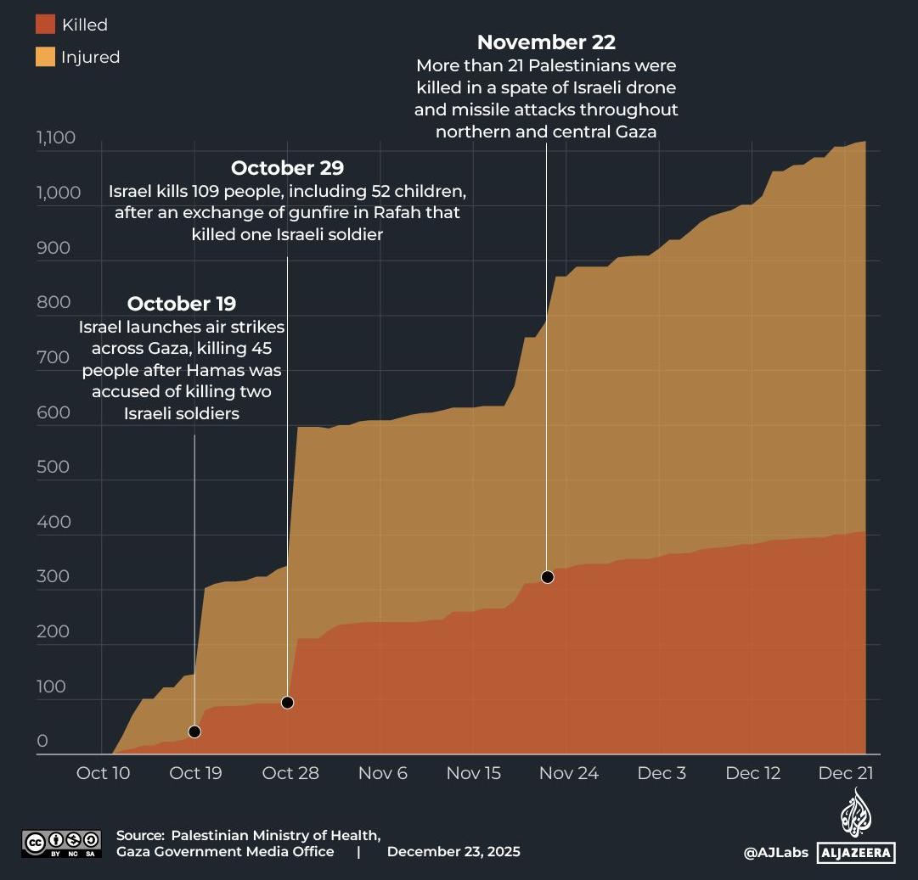

Figure #1 The number of injured and killed individuals in Palestine from October 10th to December 23rd.

It is often uttered by Palestinian children in Gaza that “the children here don’t grow up”. It is the uncertainty of life that many children face in these active conflicts. The fear of not knowing if tomorrow will be another day lived or the end is the reality faced by over 520 million children who reside in active conflicts; that is 1 out of 5 of the child population. It is the violence, hunger, thirst, rooflessness, exhaustion, trauma, that forces these children to death if not near death. Some of these are the victims of accidental civilian casualties, like adults, but some suffer a much harsher fate; directly targeted attacks or offenses towards them. Conflicts often target children as they generally have less of an ability to protect or fight for themselves when compared to adults, both physically and mentally. Thus, they are forced or manipulated into situations they did not voluntarily want to be a part of. It is not only the risk of death faced by children as there are a multitude of other causes that could lead to their suffering and need for help. To better define and create a foundation for future support for the affected children of war, the United Nations Security Council (UNSC) established the “six grave violations” in 1999 in a resolution, those being:
- Killing and maiming of children;
- Recruitment or use of children as soldiers;
- Sexual violence against children;
- Abduction of children;
- Attacks against schools or hospitals;
- Denial of humanitarian access for children.
In 2024, the UN reported 41,370 cases of grave violation, a 25% increase from the previous year. 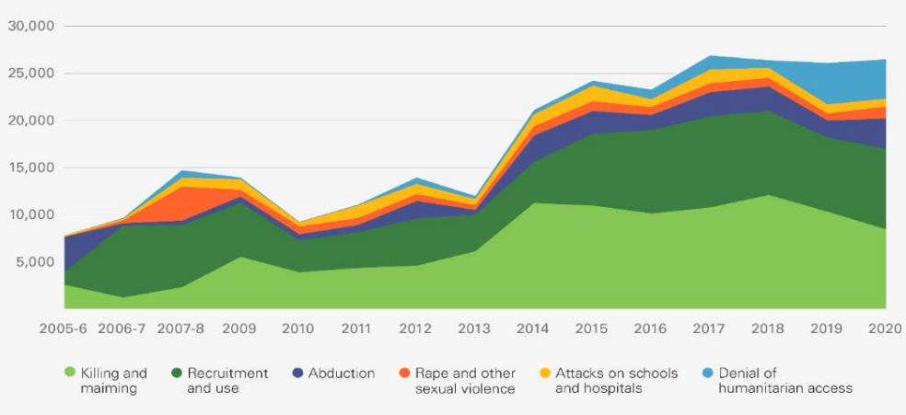

Figure #2 Number of grave violations against children over time

Definition of Key Terms

Active state-based conflicts
Armed clashes between parties where governmental bodies are involved. These clashes could be both internal and international, with it between separate state governments or between organized groups against the government. It is often to gain sovereignty or recognition over the population of an area that these clashes occur.
Grave violations
Acts that infringe upon one’s human rights in the time of conflict. These acts create suffering and causes additional difficulties in the victims’ lives and are unacceptable under international law. The UNSC has listed six grave violations that regard children in 1999, listed above.
Child soldiers
Individuals that are under the age of 18 who participate in armed conflicts to assist a particular side via performing tasks that positively benefit the particular side such as but not limited to combat, tending wounds, and message spreading.
Maim
The act of inflicting harm that causes permanent damage to one’s body, often accidentally or intentionally dealt upon at the time of conflict.
Stigma
To view a certain circumstance, quality, or person negatively. Those who experience stigma may face social disapproval and discrimination. It stems from the fear and misconceptions held by the community.

History & Developments

Ethics and regulations
Throughout recorded history, humans have always been aware of the ethical importance of child protection, due to the aforementioned reason of children being less capability to protect themselves than adults. Furthermore, children have not lived as long as adults have, meaning that they have more time to develop and future potential. Such acts of unjust treatment of children were often seen as cowardice as it is and evidently unfair fight. This awareness created a bias in people when it came to unjust/harmful acts against children. People were scared to do such actions as it was against their sense of morality.
However, everyone has their own sense of morality, their own extent of was actions are justifiable. This is the reason some kill, steal, rape, etc. In their minds, they believe one is fine to do such actions as they have lesser moral standards. This is why there is a need for laws and regulations so those who break moral boundaries will be punished, discouraging their actions and protecting those who may be harmed by their actions.
The Code of Hammurabi is one of the oldest and most well-preserved legal texts found in the ancient world. The text is composed of 282 rules which were written on a large finger-shaped stone pillar between 1755BCE to 1751BCE. The text was meant to bring justice and order to the first dynasty of Babylon. On this text, were 3 instances where it revolved around children. The 14th rule declares that all those who steal the child of another person should be executed. The 137th rule ensures that all children of split families live a quality life by obligating the man, at the time the one who worked and had a source of income, to provide parts of his land to the woman so that the child would have a home. The 185th rule allows children to be adopted and raised till they’re fully grown. These sets of rules demonstrate how in the far past, children still had special rights that protected them from danger and misery.


Figure #3 An image of the Code of Hammurabi both from a distance and zoomed in.

Children in military
Manpower has always been a major aspect of war. The more people involved, the more there are of people doing a certain task, increasing its efficiency. The more people fighting, the more force is being exerted. Thus, it would be efficient for a conflicting party to enlist children into their military force to aid in the battle. From 2005 to 2022, more than 105,000 children were involved in the military of conflicting parties. These children are deemed as “child solders” and are exploited into active conflicts to aid in the conflict via accomplishing a variety of tasks depending on the context. In the Children and Armed Conflict Annual Report of 2024 summary, 7,402 children were involved in fighting during active conflicts.
There may be a variety of reasons why a child may end up serving in the military. Often, it is through propaganda which targets a child’s naivety to influence causing the child to feel a need to serve. The need could be to escape poverty, to gain fame, to provide for the nation, to fight evil, etc. However, some have been involuntary forced into the military through threats or abduction.
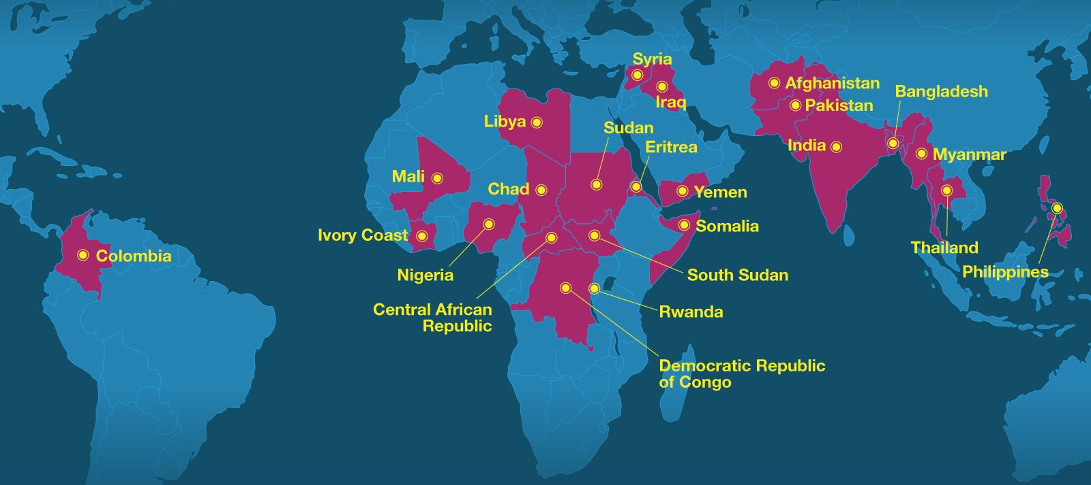

Figure #4 Reports of child soldier usage across the world since 2010.

Examples of past children in military
Children have been shown to participate in the military through legends, myths, and art which may have been inspired by real-world events. Such example is the Children’s Crusade of 1212 where it was said that 30,000 children attempted to march to Jerusalem in the hopes of converting the Muslims to Christianity. As they arrived near the Mediterranean Sea, they believed that the sea would part, allowing them to pass through. However, it didn’t, thus some of the children chose to travel via ship to cross the sea. Those who traveled on ships were said to be sold into slavery in Tunisia or died in a shipwreck. This event demonstrates the dangers children can put themselves into during conflict when unattended due to their simple understanding of the world, being unable to critically assess situations due to their tendency to use fast thinking.
In the Middle Ages, the boys of aristocratic decent were often sent away at the age of seven where they would provide service for their caretaker. In this process, the boys would be subjected to military training and taught how to fight in case of a battle. The military training was generally to prepare them for their adulthood so that they could act as soldiers in conflict. However, if there is a large conflict such as a siege occurring while the child is still in training, they may be recruited to participate in the fight. The children in battle would be given crossbows where they can shoot at enemy forces at a distance, reducing the risk them being harmed themselves.
The Ottoman Empire had soldiers known as “Janissaries”. These forces would consist of abducted children of non-Muslim faith who were kidnapped from the area or from conflicts against Christians. The system was called “devshirme”, translated to be “lifting” or “collecting”, as they believed they were saving the lives of these children from eternal damnation. The Janissaries acted as personal slaves and soldiers for the sultan, after being forcefully circumcised and converted to Islam. Events like the Conquest of Constantinople and the Battle of Mohács both involved Janissaries as a part of the military force.
During the American Civil War, children were recruited as “drummer boys” to participate in the conflict. These children would carry a large drum near their waist as well as drum sticks for beating the drum. These units were used to communicate messages through specific drum beats during battle as drums were loud, their sounds are easily recognizable in the deafening sounds of war. However, since they were on the battlefield, many were harmed, injured, even killed. Some of these drummer boys were as young as 8-9 years old with the youngest death at 12.
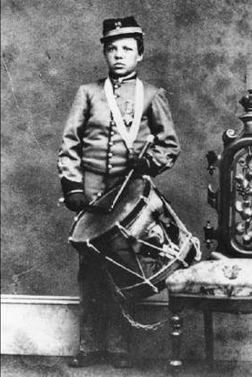

Figure #5 An image of a 12-year-old drummer boy during the American Civil War.

Phycological effects of children in military
The most reported phycological effect on child soldiers is post-traumatic stress disorder (PTSD), which causes the individuals to have trouble reintegrating into society and leading to extensive use of addictives. A 2004 interview with 301 past Ugandan child soldiers had 97% of them reporting to have experienced PTSD because of their past experiences as a child soldier. Another study in 2005 with a smaller sample on past Sri Lankan child soldiers reported 85% experiencing PTSD. A variety of other studies in the 2000s on Mozambique, Sri Lanka, and Uganda demonstrated individuals may face increased negative emotions such as stress, anxiety, fear, and even experience flashbacks.
Most of these victims of PTSD are able to advance through their life, never forgetting but recovering from their past mental scares. They are able to grow up and become regular adults, functioning through everyday life with ordinary behavior. However, a minority of those have experienced trauma at such a young age that its effects permanently altered their behavior and ability to fit into daily life. They may develop to become more aggressive and insecure.
It is common in times on conflict for child soldiers to be given addictives like tobacco and drugs to allow them to persist while waying down the negative emotions. Contacts with addictives at a young age may lead the body to become more susceptible to addiction as the mind and body are not fully developed. A 2003 study on Congo showed that the consumption of tobacco, drugs, and alcohol were much more common in child soldiers than regular children.

Sexual violence
People crave sexual actions/intercourse as they boost the release of hormones such as dopamine which allows for the sense of gratification. It reduces stress as it distracts the mind for a certain amount of time. This, during the time of war may feel extremely desirable as war can be physically and emotionally tiring. The craving of sexual tension can bring people to do indescribable acts of horror. It is the promotion of self-pleasure at the cost of another’s wellbeing. Women are the main victims of these horrors as they typically have less in strength when compared to men due to physical differences, making it harder for them to defend for themselves when assaulted. From 2022 to 2023, in a mere one year, sexual violence rates doubled, with 95% of them being women or girls. It is even harder for a child to defend oneself as they have not yet fully physically developed. 35% of the sexual violence was towards children. There was a 50% increase in this violence from 2020 to 2024, 35% from 2023 to 2024, with a drastic increase in gang rapes in the year. The UN reported at least 1,938 to 1,982 children who were victims of sexual violence in 2024, with the most coming from Haiti with 566. Other nations with high rates of sexual violence towards children in conflicts include Nigeria, the Democratic Republic of the Congo, Somalia, and the Central African Republic.

Effects of sexual violence
Sexual violence towards children could cause physical, emotional, and social damage to the victim’s life, creating extensive suffering. Sexually transmitted diseases such as HIV may infect the victim, especially if it is a gang rape where multiple people are involved, increasing the probability. HIV targets the body’s immune system, weakening it and making it more prone to future infections. Furthermore, sexual violence could lead to early pregnancies where the resulting child born from rape and their parent are forced to reside with the conflicting group as they are resource dependent on them. There may also be difficulties of return as there are social stigmas against girls who have been raped due to cultural beliefs and biases. Children raised in these conditions are often forced to live a life of crime through actions such as but not limited to stealing, prostitution, and human trafficking to earn a living. There is emotional damage that comes with sexual violence as well such as the rise in insecurity and PTSD.

Modern examples
Haiti is listed to be the nation with the most committed sexual violence against children in 2024, with 566 reported incidences. The nation is currently going through a phase of instability where the government and law enforcement are losing control of power to gangs who have been endorsed by elites for years through corruption. The gangs have formed a coalition to fight against the government to earn control of the nation. These gangs hold control of more than 80% of the capital, Port-au-Prince. Within a year, from 2023 to 2024, the sexual violence on children increased by 1000%. It is believed that rape is used as a war tactic to install fear in the public to force obedience in the people. Often the victims of these violences do not report to authorities in fear of being punished. “The bandits don’t care about their age”. “They rape because they have the power. Sometimes they do it for days or weeks,” said a humanitarian aid worker.
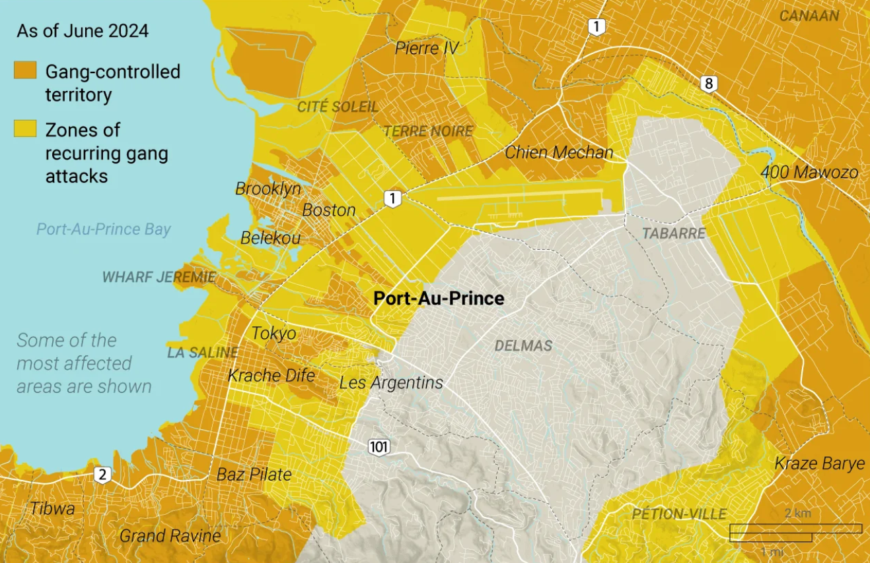

Figure #6 A map of the Haiti capital and its gang presence as of June 2024.

The Democratic Republic of the Congo (DRC) is one of the aforementioned nations with a high rate of sexual violence towards children with a reported 358 cases in 2024. The conflict in the DRC began in 2022 when Rwanda actively supported the March 23 Movement (M23) rebel group who tried to expand their influence and take power in eastern DRC. The Rwandan military itself also has 4000 troops within eastern DRC. It is another battle to gain control and power. From 2023 to 2024, there was an almost 30% in sexual violence towards children. Children would be forcefully abducted and put into sexual slavery, where they would be continuously forcefully raped.
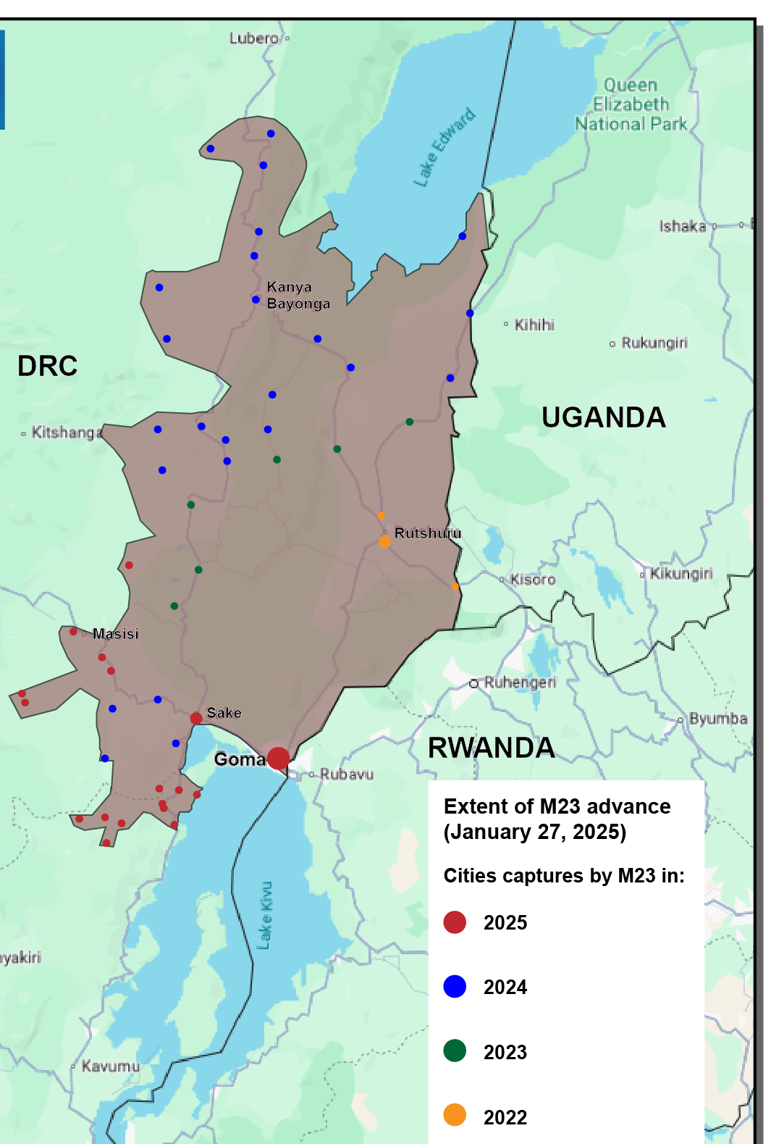

Figure #7 A map of the DRC eastern border and its M23 presence as of January 2025.

Abduction
The abduction of children at times of war can be a gateway to other violations such as military recruitment and sexual and/or physical violence. The act is executed during war as a way of threatening and controlling the people as well as ensuring the sustaining of the conflict. Children would be taken away from their known location without the consent of their guardians and transported to a secretive location where they would be stored or killed. This could be done not only through forceful removal, but also with threats and manipulation. Abductors would often target areas with a large gathering of children such as but not limited to school, temples, churches, mosques, and playgrounds to abduct a large number of children in a short amount of time. In addition to abduction being used as a tactic of public coercion, the children themselves could also hold value. If the children are not directing killed after the abduction, they could be used for purposes that benefit the abductors. These purposes are highly based on gender where boys would typically be forced into military while girls would be subjected to sexual violence and forced marriage. Other purposes of child abduction could be for organ selling, ransom, enslavement, child laundering, child labor, etc. The UN has reported 4,573 cases of child abduction in 2024, though the number is likely much higher due to unreported cases.
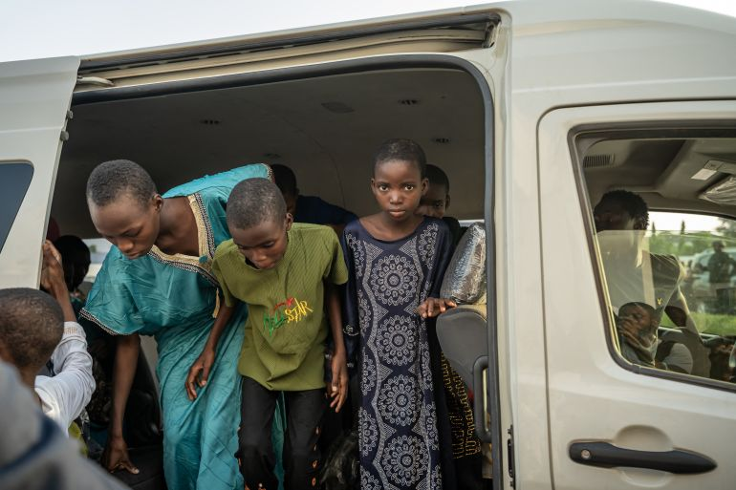

Figure #8 Nigerian children who have previously been abducted, image shown them after being rescued in November 2025.

Instances of child abduction in conflicts are found throughout history to aid in a force’s agenda. These events are usually disguised as an act of protecting or educating the underprivileged children; however, they were often forcefully taken away from their homes without the consent of their guardians and enforced by legal injuries to do so. For example, in 1869, the “Aboriginal Protection Act” was passed by Australia under the British government. The act gave the government full control over the lives of Aboriginal individuals including where they could work, where they stay, their social life and marriage, ownership of their children, what they could wear, and other aspects of their everyday lives. This was to “protect” the Aboriginal people as they were viewed as too barbaric and incapable of making their own decisions. This act led to the “Stolen Generations” event from the 1910s to 1970s where tens to hundreds of thousands of children were forced to be separated from their families to be re-educated under Christann values and work as child labor. The total number of children who were separated from their parents ranges from 25,00 to 100,00. The children often never get to see their families, working through their lifetime in slave-like conditions and having their entire lives controlled by the government. Children also faced rape under these conditions with 17% of females and 7.7% of males reported to have faced sexual abuse after their separation from their families.
An additional example was doing December 12, 1935, Nazi Germany created Lebensborn; an association of facilities with the initial goal of increasing the pure-bred Aryan population through an increase in children birth. It was a place where pregnant women could reside while and after giving birth during which they would being cared for by nurses, similar to a maternity home. The facilities were a popular spot for unmarried women to give birth as it allowed for them to give birth without their family’s and community’s knowledge, letting the avoid the social stigma of getting pregnant and giving birth while unmarried. 60% of the mothers who gave birth in Lebensborn were unmarried. However, with the beginning of WWII, the purpose of Lebensborn began to change. In 1939, children of neighboring countries were abducted after conflict and forced into Lebensborn facilities. The act was to spread Nazism across people through educating them while they are young, saving them from their past wrong ways. There, they would be subjected to forced labor and re-educated. Claims of between 100,000 to 200,000 children and forced into these facilities, with less than 15% of them returning to their original parents. All of this was kept under a façade with its original purpose.

Major Parties Involved

Save the Children
Save the Children is an international non-governmental organization (INGO) created by a pair of sisters in London on April 15th, 1919. Initially, it was created with a goal to to aid children who were suffering from food shortages in Germany during WWI. As the war finished, the organization continued to be involved in places of conflict and aiding children. This was through gaining public funding, allowing them to raise money to support children in conflicting areas and raising awareness of these issues. These actions allowed the organization to gain popularity and recognition across the world, allowing them to collaborate with other organizations like the UN. In 1923, one of the founders of Save the Children, Eglantyne Jebb, drafted the Geneva Declaration and submitted it to the League of Nations, with in being adopted in 1924. This was the basis for what later became the Convention on the Rights of the Child adopted 1989, which was laid foundation to addressing child protection in warzones in the modern world. As of 2024, Save the Children has supported 113 countries, supported 113.6 million children, and caused 122 policy changes across the world. Their current goal is to empower health, resilience, education, and protection of children through their actions.

International Criminal Court
The International Criminal Court (ICC) is the only permanently existing court that has the ability to prosecute individuals for violation of international law. Following the world wars, nations realized the importance to punish violators of humanitarian crimes. The court was founded in 2002 as an effect of the Rome Statute treaty of 1998. The treaty created a consensus and defined how international law would be regulated and enforced. It stated the four core international crimes of Genocide, Crimes Against Humanity, War crimes, and the Crime of aggression. Individuals who committed those crimes would be detained and trialed; imprisoned if found guilty. The treaty received 137 signatures on the day it was drafted. The ICC is the follow-up of this treaty, the court where the trials are held. There are 125 member states who recognize the ICC, with 12 of the previous signatures either not responding, dropping out, or reversing their signatures. The ICC is not recognized by major nations like the U.S., Russia, India, and China. The ICC is involved in punishing those who violate grave violations against children.
Israel and the Occupied Palestinian Territory
The Israeli–Palestinian conflict has been reported to have the highest number of grave violations out of all active state-based conflicts in 2024. There are 8,554 verified grave violations against 2,959 children, 2,944 of which are Palestinian and 15 of which are Israeli. Compared to the total amount of grave violations committed in 2024, the conflicts cover over 20% of all 41,370 grave violations across the world. The Gaza strip accounted for 4,856 violations and the West Bank accounted for 3,688 violations. 1,356 Palestinian children were killed and 1,561 were maimed in 2024, with a majority of deaths and injuries caused by live ammunition and air strikes. There were 502 attacks on schools and hospitals and 5,091 cases of denial of humanitarian aid. The full report of violations is listed here: (A/79/878-S/2025/247).

Continent of Africa
40% of all active state-based occur on the continent of Africa, a 45% increase since 2020. The conflicts arise due to a multitude of social and environmental factors that drive competition and violence. Africa has the youngest median age out of all continents at 19.3. However, many struggle financially, not being able to make a living for themselves or their family. 35.5% of the population is in extreme poverty and 36 million people are unemployed. This lack of financial resources forces many children and young adults to join rebel groups and live a life of creating instability and committing crime. Additionally, around 30% of Earth’s minerals are located in Africa, with an export value worth $265 billion dollars. This provides the motive for governments and groups to want to gain control as additional control over an area could mean additional wealth. These conflicts sustain and cause continuous civilian suffering as humanitarian aid to the area is underfunded, with only 40% of the need funding given in 2024. With the growing conservation across the world, government like the Trump Administration in the U.S. have completely stopped funding on the continent.

Timeline of Events
Depending on the subject, this section may not be entirely necessary. Bringing clarification is still advised, though. Please chronologically list the major events that occurred for the topic.
Date | Event Name | Description
September 26, 1924 | Adoption of Geneva Declaration | The first declaration adopted by the League of Nations that specifically addressed the rights of children rather than generalizing as all “human”.
November 20, 1959 | Adoption of Declaration of the Rights of the Child | Modification and improvement on the Geneva Declaration adopted by the UN after the League of Nations fell apart.
November 20, 1989 | Adoption of Convention on the Rights of the Child | Defined that a “child” is a person below the age of 18.
August 25, 1999 | Recognition of the six grave violations | Allowed for nations to define when a child is being exploited and to condemn the violator.
July 1, 2002 | Establishment of the International Criminal Court | The first and only permanent court that holds trials for international crimes committed by individuals was created
July 26, 2005 | Monitoring and Reporting Mechanism report on grave violations | The creation of a system of document grave violations in conflicts through on-site observation.

Previous Attempts to Solve the Issue
The Geneva Declaration was adopted by the League of Nations in 1924 as the first internationally approved declaration that targeted the rights specifically of children. The document was drafted by Eglantyne Jebb, a founder of the Save the Children organization, in 1923 after she had recognized the need for additional protection and aid for children following WWI. The declaration stated 5 points of the various needs a child must obtain from adults to ensure the well-being of the child. In 1934, the General Assembly of the League of Nations once again approved the declaration with various nations providing signatories that they would implement these rules in their national law. However, the document was not legally binding, meaning that there would be no consequences if the nations did not implement these rules.
A modified version of the Geneva Declaration was adopted by the UN in 1959 after the fall of the League of Nations. The document was called the Declaration of the Rights of the Child. This modification expanded the document to 10 points rather than the previous 5 with additional inclusion of things such as but not limited to free education, special education for children with disabilities, and equality.
The Convention on the Rights of the Child was a treaty signed by 140 nations in 1989. It was a legally binding treaty, meaning that all signatories must implement the contents of the treaty under international law. The treaty allowed children to have their own opinions and views, even if they may alter from their parents. These opinions should be able to be voiced and heard without being hidden. The treaty also allowed for privacy protection of children. The main point of the treaty was that it defines a “child” as an individual under the age of 18.
The six grave violations were listed in Resolution 1261 adopted by the UNSC in 1999. This was to properly define what child exploitation was and identify when and in what situation should a child gain protection. In 2005, in order to gain statistics on the violations to create solutions, the UNSC designed the Monitoring and Reporting Mechanism (MRM) in Resolution 1612. The MRM is meant to gather information on grave violations and active conflicts and report them back to the UN. This is done through the Country Task Force on Monitoring and Reporting (CTFMR) where teams would report on-location and be involved in deescalating and solution-making of conflicts.

Relevant UN Treaties and Events
- Convention on the Rights of the Child, 20 November 1989 (A/RES/44/25)
- Optional Protocol to the Convention on the Rights of the Child on the Involvement of Children in Armed Conflict, 25 May 2000 (A/RES/54/263)
- Rome Statute of the International Criminal Court, 17 July 1998 (A/CONF.183/9)
- Children and Armed Conflict, 30 August 1999 (S/RES/1261)
- Protection of Civilians in Armed Conflict, 19 April 2000 (S/RES/1296)
- Children and Armed Conflict, 20 November 2001 (S/RES/1379)
- Children and Armed Conflict, 30 January 2003 (S/RES/1460)
- Children and Armed Conflict, 22 April 2004 (S/RES/1539)
- Children and Armed Conflict, 26 July 2005 (S/RES/1612)
- Children and Armed Conflict, 4 August 2009 (S/RES/1882)
- Children and Armed Conflict, 12 July 2011 (S/RES/1998)
- Children and Armed Conflict, 25 July 2013 (S/RES/2117)
- Children and Armed Conflict, 18 June 2015 (S/RES/2225)

Possible Solutions
It is difficult to regulate and enforce international law as the forcing of a nation to adopt such laws would be a violation of their sovereignty. International bodies like the International Court of Justice (ICJ) and the ICC are not recognized by many nations; thus, they are unable to impose rules and punish violators who reside in these nations. There is no way of punishing Israeli forces, for example, for their grave violations as Israel is not a member of the ICC. Nations and groups are able to get away with committing international crimes while ignoring their punishments. There is a need to craft better legal legislation, both nationally and internationally, that ensures the rightful punishment of violators of international crime.
Currently, the CTFMR is involved in solely observing and reporting grave violations in active conflicts. There is missing potential to impose direct actions to directly combat these grave violations on spot instead of relying on formulated treaty-based solutions. Drafting a solution to create a consensus between the conflicting parties could take an excess amount of time. When observing violations happen, there could be action to directly stop it. There could be an expansion in the MRM where the CTFMR consists of a broader array of personnels such as but not limited to bodyguards, medics, caretakers so that they could take action to support children in danger during conflicts.
As aforementioned, only 40% of Africa’s needed funding was provided in 2024. There is a lack of awareness and public empathy towards many of these conflicts. Without the public knowing about a conflict’s existence, it would be less favorable for a nation to provide funding as no one would see it. As a result, NGOs could fund digital and physical campaigns to raise awareness of lesser-known conflicts to gain public interest. This will provide a motive for developed nations to provide additional funding and resources for humanitarian aid in warzones.

Bibliography
Works Cited
AJC. “Who Are the Hostages Still Held by Hamas?” Ajc.org, American Jewish Committee , 3 Apr. 2025, www.ajc.org/news/who-are-the-hostages-still-held-by-hamas.
AJLabs. “How Many Times Has Israel Violated the Gaza Ceasefire? Here Are the Numbers.” Al Jazeera, 11 Nov. 2025, www.aljazeera.com/news/2025/11/11/how-many-times-has-israel-violated-the-gaza-ceasefire-here-are-the-numbers.
Al Jazeera. “Crimes against Children in Conflict Zones Surge in 2024: NGO.” Al Jazeera, 4 Nov. 2025, www.aljazeera.com/news/2025/11/4/crimes-against-children-in-conflict-zones-surges-in-2024-ngo.
---. “Rwanda, M23 and the Conflict in Congo Explained | Start Here.” YouTube, 1 Mar. 2025, www.youtube.com/watch?v=-xSSoIOxP3E.
---. “Why Africa Has Become a Hotspot for War | by the Numbers.” Www.youtube.com, 31 Oct. 2025, www.youtube.com/shorts/XxmE69bhhhg.
Al Shazly, Mohamed Sulieman. “The International Criminal Court: A Historical Background and Growing Challenges.” Human Rights & Public Liberties, Al Jazeera, 3 Dec. 2024, liberties.aljazeera.com/en/the-international-criminal-court-a-historical-background-and-growing-challenges/.
BBC. “Who Are the Released Hostages?” BBC, 4 Dec. 2025, www.bbc.com/news/articles/cpvl9k4mw8no.
Butcher, Emma, and James Rogers. “Innocence under Fire: How Children Were Used in Warfare of the Past.” HistoryExtra, BBC, July 2017, www.historyextra.com/period/first-world-war/how-children-used-warfare-fighting-child-soldiers/.
Cook, Daphnee. “Sexual Violence against Children in Conflict Surges 50% in 5 Years to Worst Level Ever.” Save the Children International, 2025, www.savethechildren.net/news/sexual-violence-against-children-conflict-surges-50-5-years-worst-level-ever.
Galal, Saifaddin. “Africa: Number of Unemployed People 2012-2023.” Statista, 28 Nov. 2025, www.statista.com/statistics/1286935/number-of-unemployed-people-in-africa/.
Human Rights Watch. “Haiti: Scarce Protection as Sexual Violence Escalates.” Human Rights Watch, 25 Nov. 2024, www.hrw.org/news/2024/11/25/haiti-scarce-protection-as-sexual-violence-escalates.
Humanium. “Declaration of the Rights of the Child, 1959 - Humanium.” Humanium, 2011, www.humanium.org/en/declaration-rights-child-2/.
---. “Geneva Declaration of the Rights of the Child, 1924 - Humanium.” Humanium, 2019, www.humanium.org/en/geneva-declaration/.
IEP. “Global Peace Index 2025: Identifying and Measuring the Factors That Drive Peace.” June 2025.
Johnson, Mirindi. “Sexual Violence against Children “Entrenched” and Rising across Democratic Republic of the Congo – UNICEF.” Unicef.org, 19 Dec. 2025, www.unicef.org/press-releases/sexual-violence-against-children-entrenched-and-rising-across-democratic-republic.
joyelliott. “Protection of Children Must Be Priority in War and Conflict Settings.” Plan International, 6 June 2023, plan-international.org/blog/2023/06/06/protection-of-children-must-be-priority-in-war-and-conflict-settings/.
Kuperminc , Julia. “Preventing Sexual and Gender-Based Violence in Haiti - New Lines Institute.” New Lines Institute, 3 Oct. 2024, newlinesinstitute.org/gender/preventing-sexual-and-gender-based-violence-in-haiti/.
Machel, Graça. Progress and Challenges for Children since the 1996 Publication of Graça Machel’s Report on the Impact of Armed Conflict on Children. Aug. 2021.
Межа. “Child Abduction in Conflicts: Historical Cases and Modern Legal Actions.” Ukraine News - #Mezha, Межа, 24 Oct. 2025, mezha.net/eng/bukvy/child-abduction-in-conflicts-historical-cases-and-modern-legal-actions/.
Onion, Amanda, et al. “Code of Hammurabi: Laws & Facts | HISTORY.” HISTORY, 9 Nov. 2009, www.history.com/articles/hammurabi.
Outreach International. “Poverty in Africa.” Outreach International, 26 Sept. 2023, outreach-international.org/blog/poverty-in-africa/.
Rowlands, Lyndal. “Nigeria Secures Release of 100 Kidnapped Children, Reports Say.” Al Jazeera, 8 Dec. 2025, www.aljazeera.com/news/2025/12/8/nigeria-secures-release-of-100-kidnapped-children-reports-say.
Ruiz, Stephen. “How a Civil War Drummer Boy Became the Youngest Medal of Honor Recipient.” Military.com, 10 Mar. 2025, www.military.com/history/how-civil-war-drummer-boy-became-youngest-medal-of-honor-recipient.html.
Save The Children. “Save the Children.” Save the Children International, 2025, www.savethechildren.net/.
Singh, Aoife R, and Ashok N Singh. “The Mental Health Consequences of Being a Child Soldier – an International Perspective.” International Psychiatry, vol. 7, no. 3, July 2010, p. 55, pmc.ncbi.nlm.nih.gov/articles/PMC6734971/#s4.
Times Originals. “Inside Haiti’s Brutal Gang War.” YouTube, 1 Aug. 2025, www.youtube.com/watch?v=J0DpA0uP_Sw.
Tremblay, Stephanie. “Abduction - United Nations Office of the Special Representative of the Secretary-General for Children and Armed Conflict | to Promote and Protect the Rights of All Children Affected by Armed Conflict.” United Nations Office of the Special Representative of the Secretary-General for Children and Armed Conflict | to Promote and Protect the Rights of All Children Affected by Armed Conflict, 2017, childrenandarmedconflict.un.org/six-grave-violations/abduction-of-children/.
---. “Sexual Violence against Children - Bureau de La Représentante Spéciale Du Secrétaire Général Pour La Question Des Enfants et Des Conflits Armés.” Bureau de La Représentante Spéciale Du Secrétaire Général Pour La Question Des Enfants et Des Conflits Armés, 16 Dec. 2020, childrenandarmedconflict.un.org/six-grave-violations/sexual-violence/.
---. “The Six Grave Violations.” United Nations Office of the Special Representative of the Secretary-General for Children and Armed Conflict, 2023, childrenandarmedconflict.un.org/six-grave-violations/.
Turki, Bella, and Ben Cheikh. “CHILDREN’S RIGHTS: FROM HAMMURABI’S CODEX to the CONVENTION on the RIGHTS of the CHILD".” 2006.
UNICEF. “Children Recruited by Armed Forces or Armed Groups.” UNICEF, UNICEF, 3 Sept. 2020, www.unicef.org/protection/children-recruited-by-armed-forces.
---. “Convention on the Rights of the Child.” UNICEF, UNICEF, 2025, www.unicef.org/child-rights-convention.
United Nations. “Child Trafficking and Armed Conflict.” Nov. 2023.
---. “Children and Armed Conflict - Report of the Secretary-General (A/79/878-S/2025/247).” Question of Palestine, 17 June 2025, www.un.org/unispal/document/children-and-armed-conflict-report-of-the-secretary-general-a-79-878-s-2025-247/.
---. “CHILDREN and ARMED CONFLICT ANNUAL REPORT of the SECRETARY-GENERAL Summary 2024.” 19 June 2025.
---. Conflict-Related Sexual Violence | United Nations. 2025, www.un.org/en/peace-and-security/page/conflict-related-sexual-violence.
---. Guidance Note on Abduction. Apr. 2022.
Vinet, Fabienne. “22,495 Haunting Cries: Children Affected by Conflict Endured an Unconscionable Number of Grave Violations in 2024.” Office of the Special Representative of the Secretary-General for Children and Armed Conflict, 16 June 2025, childrenandarmedconflict.un.org/2025/06/22495-haunting-cries-children-affected-by-conflict-endured-an-unconscionable-number-of-grave-violations-in-2024/.
Watson, Nessim. “Save the Children | International Organization | Britannica.” Encyclopædia Britannica, 2019, www.britannica.com/topic/Save-the-Children.
Yeung, Jessie, et al. “October 10, 2025 - Israel-Hamas War.” CNN, 10 Oct. 2025, edition.cnn.com/world/live-news/israel-hamas-gaza-ceasefire-agreement-10-10-25.

